**THE HISTORY OF COAL**

**Put the pictures in the correct order. Then, match the description to each picture to see where coal comes from:**

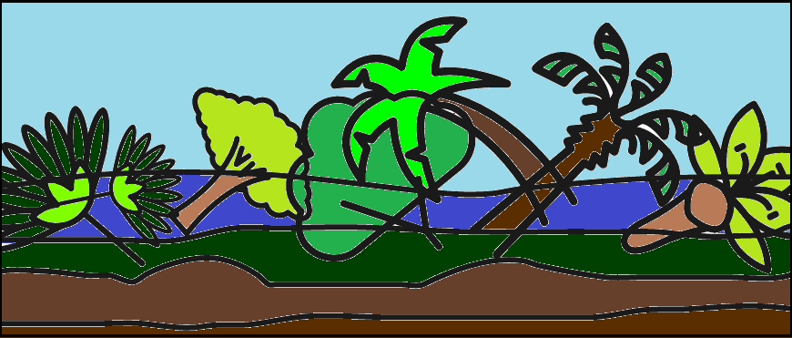 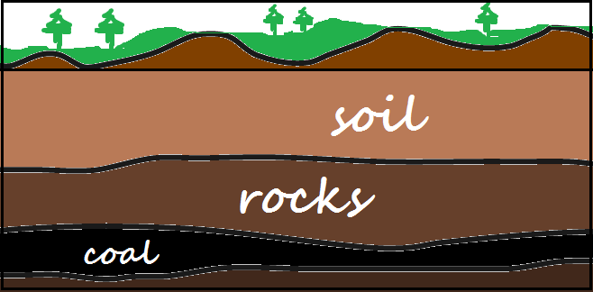 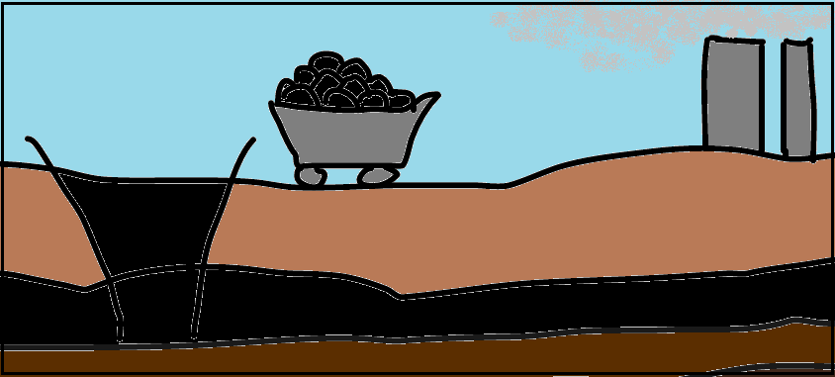

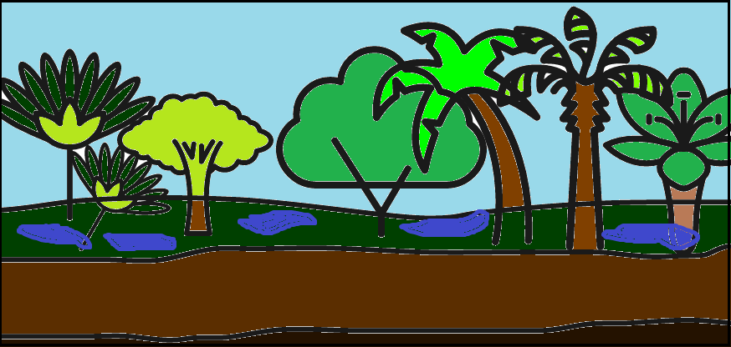 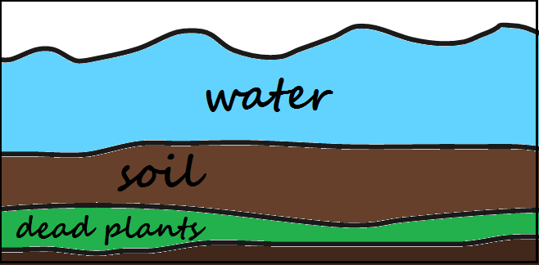

**PICTURE NUMBER:**

**PICTURE NUMBER:**

**When the giant plants died, they fell into the swamps and started decaying there.**

**Dead plants were gradually turned into coal – due to high pressures and extreme heat.**

**Millions of years ago the climate was tropical. That’s why giant plants, such as trees and enormous ferns, grew rapidly in swamplands.**

**Millions of years ago the climate was tropical. That’s why giant plants, such as trees and enormous ferns, grew rapidly in swamplands.**

**When the giant plants died, they fell into the swamps and started decaying there.**

**When the giant plants died, they fell into the swamps and started decaying there.**

**Millions of years ago the climate was tropical. That’s why giant plants, such as trees and enormous ferns, grew rapidly in swamplands.**

**When the giant plants died, they fell into the swamps and started decaying there.**

**When the giant plants died, they fell into the swamps and started decaying there.**

**When the giant plants died, they fell into the swamps and started decaying there.**

**Plants stayed under the layer of water and soil for long millions of years.**

**Plants stayed under the layer of water and soil for long millions of years.**

**Plants stayed under the layer of water and soil for long millions of years.**

**Plants stayed under the layer of water and soil for long millions of years.**

**Now, coal is excavated in mines and transported to power plants around the world.**

**Plants stayed under the layer of water and soil for long millions of years.**

**PICTURE NUMBER:**

**PICTURE NUMBER:**

**Millions of years ago the climate was tropical. That’s why giant plants, such as trees and enormous ferns, grew rapidly in swamplands.**

**PICTURE NUMBER:**

**COAL DEPOSITS IN OUR COUNTRIES**

**Write the name of each of these coalfields. Then, draw a flag of the partner country on whose territory the coalfield is situated:**

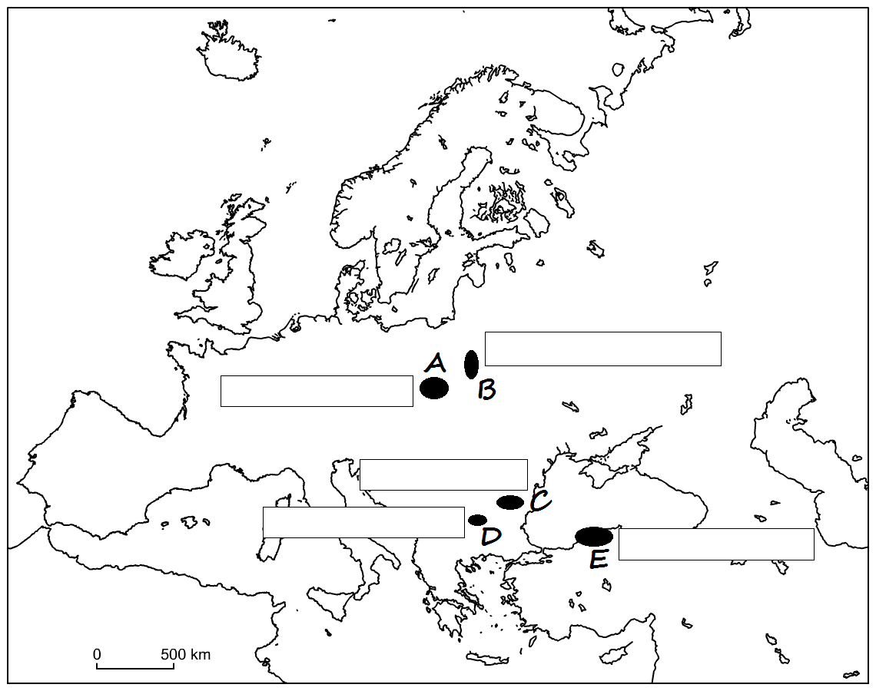

**Letter Coalfield Flag**

**The  
 Dobrudzha   
 Basin**

**The   
 Upper -  
 Silesian  
 Basin**

**The   
 Sofia  
 Basin**

**The   
 Zonguldak  
 Basin**

**The   
 Lublin**

**Basin**

**Millions of years ago the climate was tropical. That’s why giant plants, such as trees and enormous ferns, grew rapidly in swamplands.**

**ADVANTAGES and DISADVANTAGES OF COAL as an energy source**

**Study these arguments. Decide whether they are an advantage or disadvantage by putting + or – in the boxes:**

**Coal can be found in many places around the world.**

**There is enough coal for about 100 more years.**

**The work of miners is dangerous and there are many accidents.**

**To excavate coal, special mines must be built.**

**Burning coal produces greenhouse gases.**

**Coal is easy to transport.**

**Coal is not very expensive.**

**Burning coal causes air pollution.**

**Coal is a non-renewable energy source.**

**Millions of years ago the climate was tropical. That’s why giant plants, such as trees and enormous ferns, grew rapidly in swamplands.**

**Millions of years ago the climate was tropical. That’s why giant plants, such as trees and enormous ferns, grew rapidly in swamplands.**

**Millions of years ago the climate was tropical. That’s why giant plants, such as trees and enormous ferns, grew rapidly in swamplands.**

**Millions of years ago the climate was tropical. That’s why giant plants, such as trees and enormous ferns, grew rapidly in swamplands.**

**Millions of years ago the climate was tropical. That’s why giant plants, such as trees and enormous ferns, grew rapidly in swamplands.**

**Millions of years ago the climate was tropical. That’s why giant plants, such as trees and enormous ferns, grew rapidly in swamplands.**

**WAYS TO REPLACE COAL as an energy source**

**There are other sources of energy which can replace coal.   
Study these pictures and match them with the names. Then decide if the source is renewable (R) or non-renewable (N):**

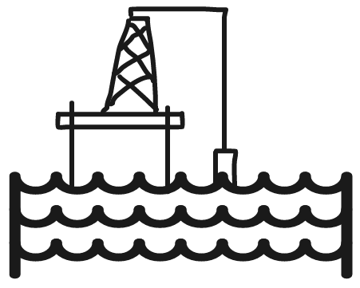 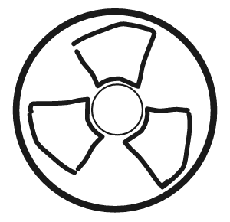 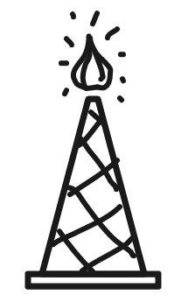

**NUCLEAR**

**WIND**

**NATURAL GAS**

**SOLAR**

**OIL**

**HYDRO-ELECTRIC**

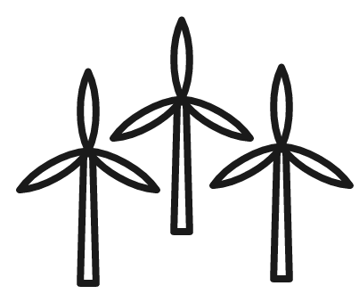  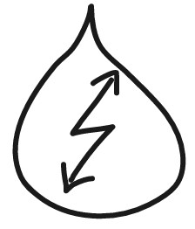

**R**

**N**

**HOW COAL IS USED TO PRODUCE ENERGY**

**Read about what happens at the coal power station. Put the stages of energy production in the correct order:**

**The heat from the burning coal turns water into hot steam.**

**Turbines move giant magnets inside coils of wire.**

**Coal is burned.**

**The magnets produce electricity.**

**Steam expands and moves the turbines.**

**Steam cools and turns back into water.**