**Kömürün tarihçesi**

**Resimleri doğru sıraya koyarak kömürün tarihçesini tanımlayınız.**

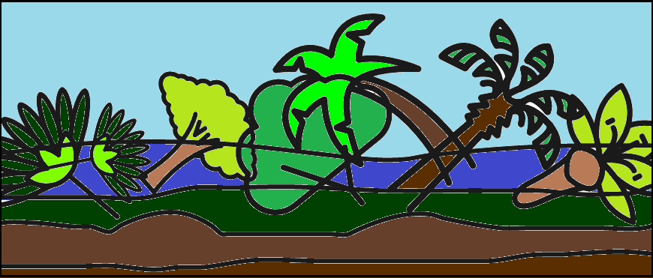 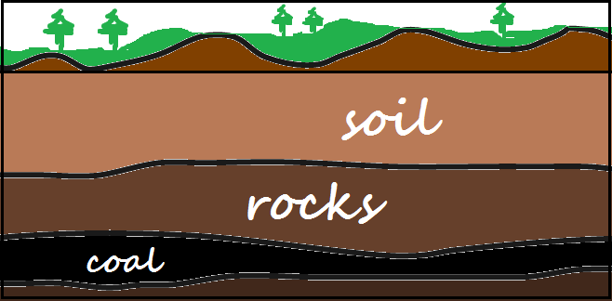 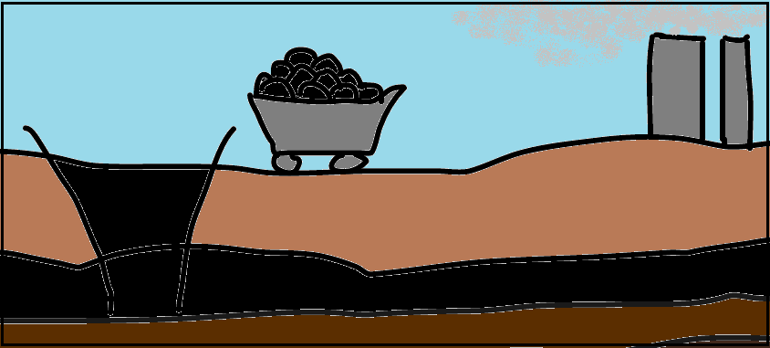

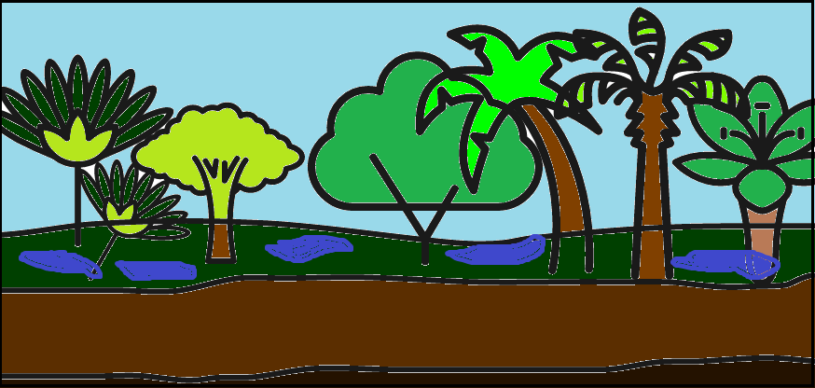 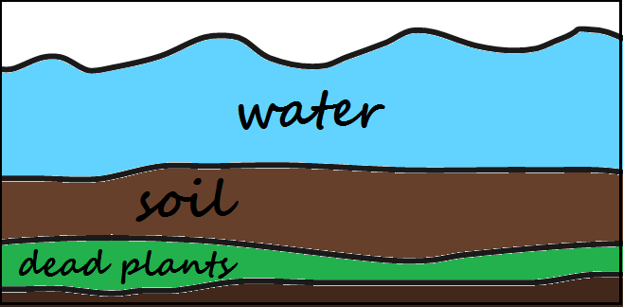

**numara:**

**numara:**

**Dev bitkiler ölünce bataklık gibi su birikintilerinde çürümeye başladı**

**Yüksek basınç ve ısıyla beraber ölü bitkiler dönüşüme uğradı**

**Millions of years ago the climate was tropical. That’s why giant plants, such as trees and enormous ferns, grew rapidly in swamplands.**

**Millions of years ago the climate was tropical. That’s why giant plants, such as trees and enormous ferns, grew rapidly in swamplands.**

**When the giant plants died, they fell into the swamps and started decaying there.**

**When the giant plants died, they fell into the swamps and started decaying there.**

**Milyonlarca yıl önce tropical iklim sayesinde dev bitki ve muazzam büyüklükteki eğreti otları bataklıkta çürümeye başlaeı**

**When the giant plants died, they fell into the swamps and started decaying there.**

**When the giant plants died, they fell into the swamps and started decaying there.**

**When the giant plants died, they fell into the swamps and started decaying there.**

**Plants stayed under the layer of water and soil for long millions of years.**

**Plants stayed under the layer of water and soil for long millions of years.**

**Plants stayed under the layer of water and soil for long millions of years.**

**Plants stayed under the layer of water and soil for long millions of years.**

**Günümüzde dünyada kazılan madenler ve santrallerde kömür rezervleri bulunmakta**

**Bitkiler milyonlarca yıl bu su ve tabaka altında kaldı**

**numara:**

**numara**

**Millions of years ago the climate was tropical. That’s why giant plants, such as trees and enormous ferns, grew rapidly in swamplands.**

**numara:**

**Ülkelerimizdeki kömür rezervleri**

**Aşağıdaki gösterilen kömür alanlarının ülkelerini yazıp bayraklarını çiziniz**

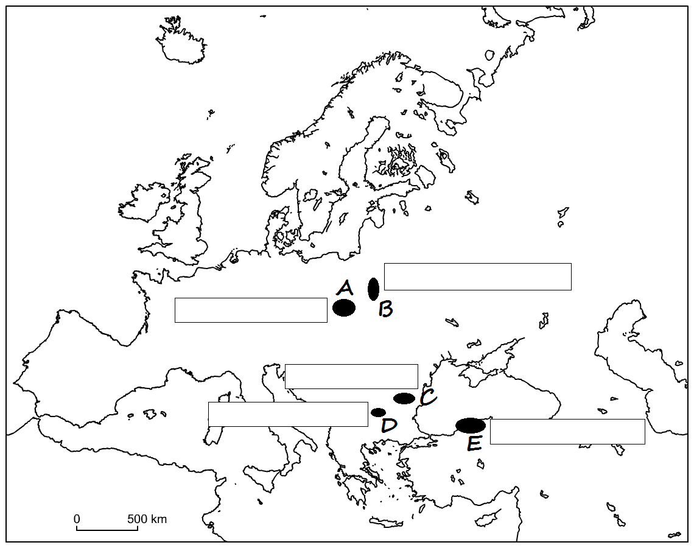

**harf bölge bayrak**

**The  
 Dobrudzha   
 Basin**

**The   
 Upper -  
 Silesian  
 Basin**

**The   
 Sofia  
 Basin**

**The   
 Zonguldak  
 Basin**

**The   
 Lublin**

**Basin**

**Millions of years ago the climate was tropical. That’s why giant plants, such as trees and enormous ferns, grew rapidly in swamplands.**

**Bir enerji kaynağımolarak kömürün avantaj ve dezavantajları**

**Cümlelere bakarak avantaj veya dezavantaj olduğuna karar verip + _ ile belirtiniz**

**Kömür dünyanın bir çok yerinde bulunabilir..**

**Yaklaşık 100 yıl daha yetecek kömür rezervi mevcut.**

**Madenciler tehlikeli ve kazaya müsait bir işte çalışıyor.**

**Kömür çıkarmak için özel mayınlar kullanılır.**

**Yakılan kömür seragazı açığa çıkarır.**

**Taşımacılığı kolaydır**

**Kömür çok pahalı değildir.**

**Burning coal causes air pollution.**

**Kömür yenilenemez bir enerji kaynağıdır.**

**Millions of years ago the climate was tropical. That’s why giant plants, such as trees and enormous ferns, grew rapidly in swamplands.**

**Millions of years ago the climate was tropical. That’s why giant plants, such as trees and enormous ferns, grew rapidly in swamplands.**

**Millions of years ago the climate was tropical. That’s why giant plants, such as trees and enormous ferns, grew rapidly in swamplands.**

**Millions of years ago the climate was tropical. That’s why giant plants, such as trees and enormous ferns, grew rapidly in swamplands.**

**Millions of years ago the climate was tropical. That’s why giant plants, such as trees and enormous ferns, grew rapidly in swamplands.**

**Millions of years ago the climate was tropical. That’s why giant plants, such as trees and enormous ferns, grew rapidly in swamplands.**

**Kömürü değiştirme yolları**

**Aşağıdakienerji kaynaklarından yenilenebilir olana r yenilenemez olana n koyunuz):**

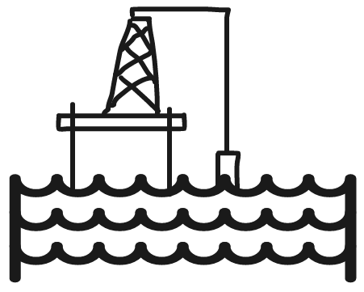 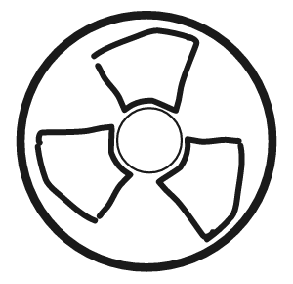 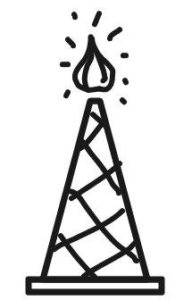

**NUCLEAR**

**rüzgar**

**doğal gaz**

**güneş**

**yağ**

**hídro elektrîk**

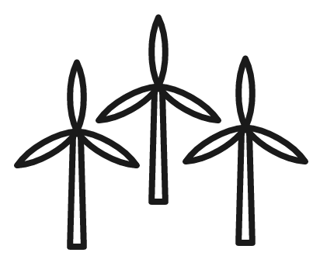  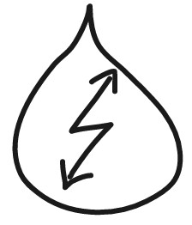

**R**

**N**

**Kömür enerji üretmek için nasıl kullanılır**

**Enerji üretim aşamalarını doğru sıraya koyunuz**

**Kömürün yanışı suyu sıcak buhar haline getirir..**

**Yrubunler dev tel bobínlerí hareket ettirir.**

**Kömür yanar**

**Mıknatıskar elektrik üretir.**

**Buhar tribünleri genleştirip hareket ettirir.**

**Buhar soğuyunca suya geri dönüşür.**