**WHERE DOES STEEL COME FROM?**

**The pictures illustrate the first stages of steel production. Look at them and try to identify some of the key agents in this process by writing appropriate letters in the boxes:**

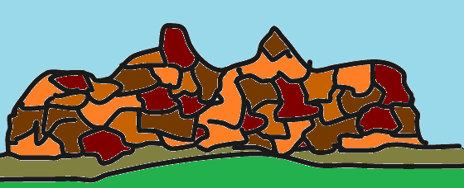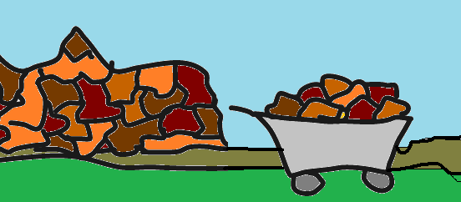  
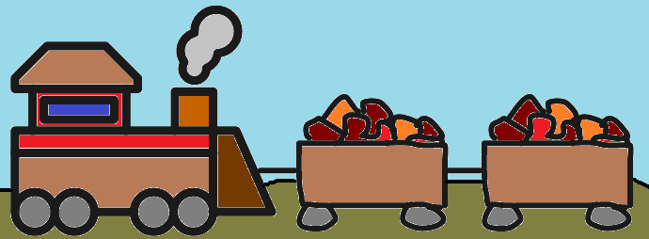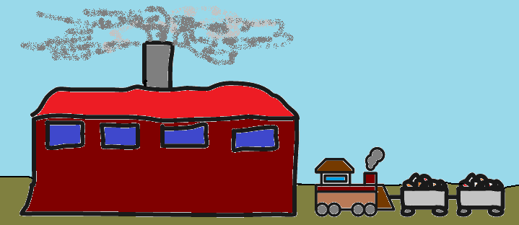

**D.**

**C.**

**B.**

**A.**

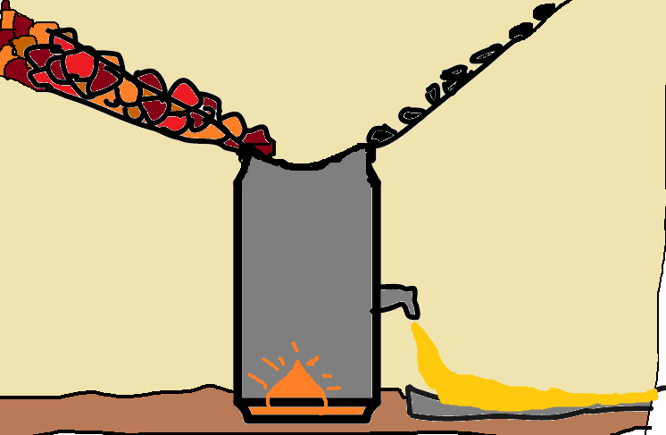

1. Carbon, nickel etc.

2. Iron ore

1. Iron ore transporting

4. Blast furnace

1. Steelworks

6. Iron ore mining

1. Pig iron

**F.**

**G.**

**E.**

**AT A BLACKSMITH’S**

**Here are some objects – tools – you could find at a blacksmith’s. Can you name them? Use these words:**

***ANVIL – CHISEL – HEARTH – HAMMER – BUCKET – TONGS – BELLOWS***

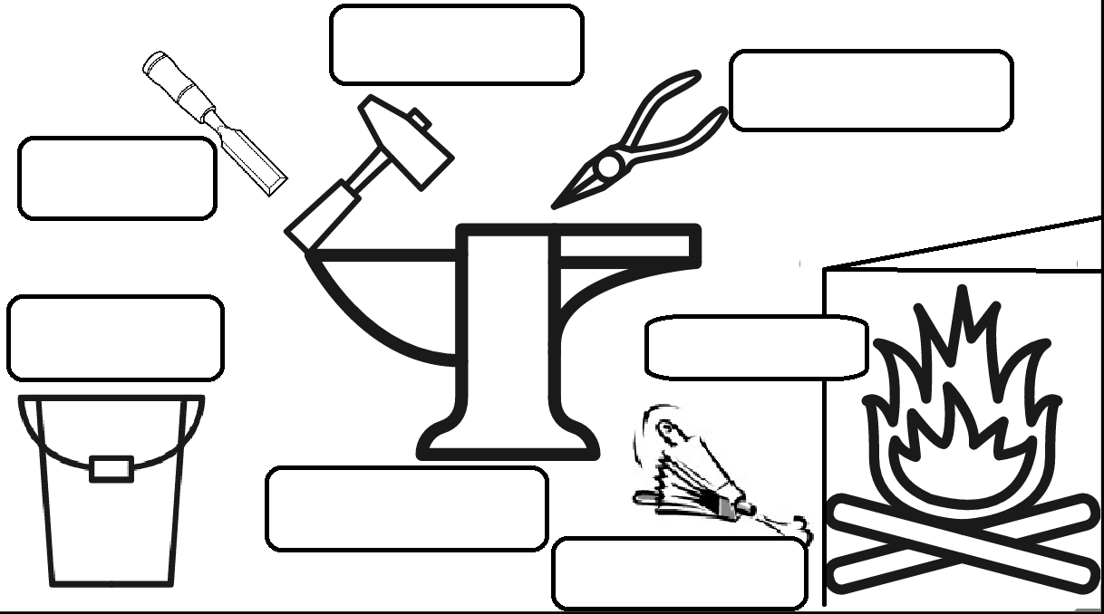

**PEOPLE WHO WORK WITH STEEL**

**All these people work with steel. Can you guess their jobs?   
Who is a: BLACKSMITH – JEWELLERY ARTIST – WELDER – STEELWORKER?**

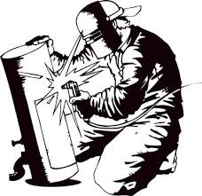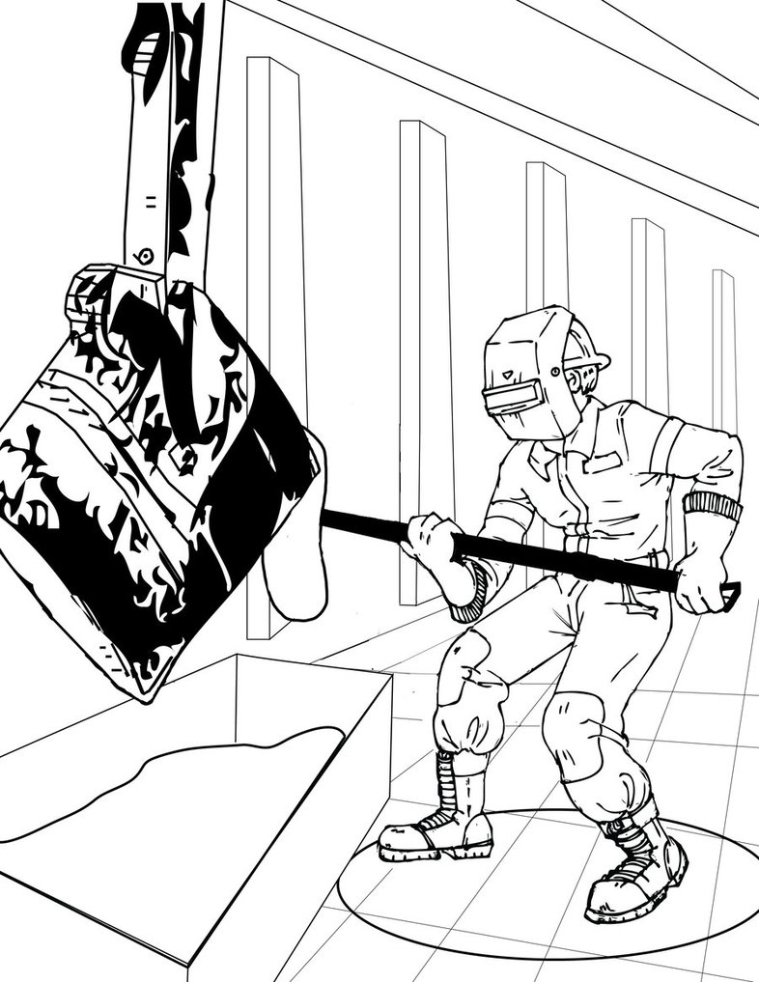

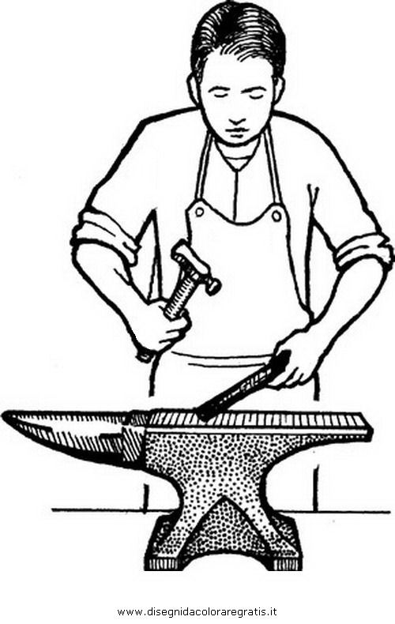

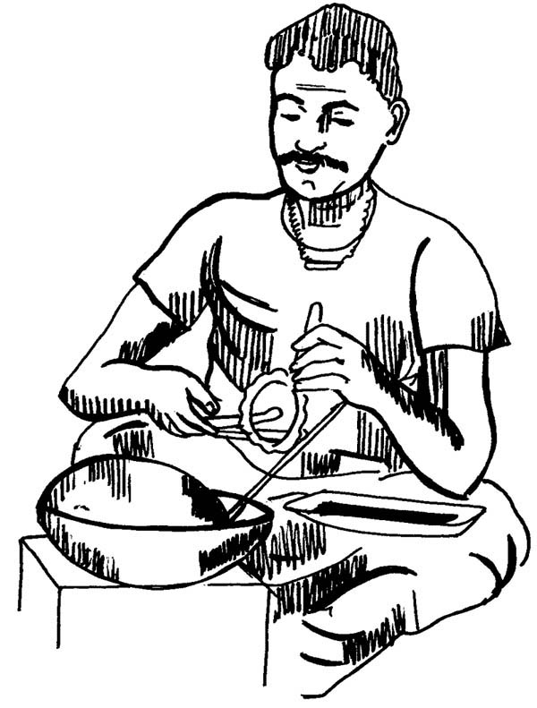

**WHAT IS STEEL USED FOR?**

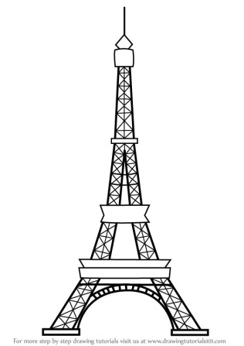**We use steel all the time and our world would not be the same without it. Here are some categories and some pictures. Match the pictures to the categories by putting letters V-H-C-P-A-E in the boxes.**

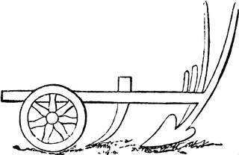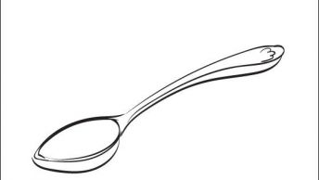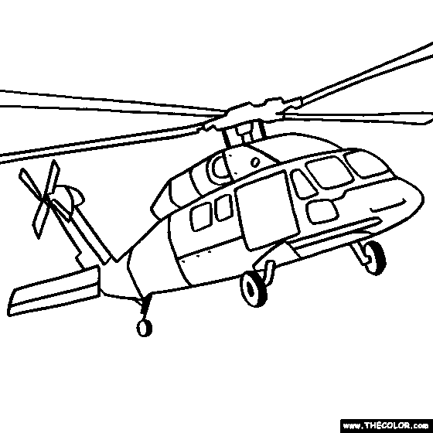

**Can you add at least THREE examples of objects containing steel in each of the categories?   
Write your ideas in the table below:**

|  |  |  |  |  |  |
| --- | --- | --- | --- | --- | --- |
| **VEHICLES** | **HOUSEHOLD APPLIANCES** | **CONSTRUCTION** | **POWER GENERATORS** | **AGRICULTURE** | **EVERYDAY OBJECTS** |
|  |  |  |  |  |  |
|  |  |  |  |  |  |
|  |  |  |  |  |  |