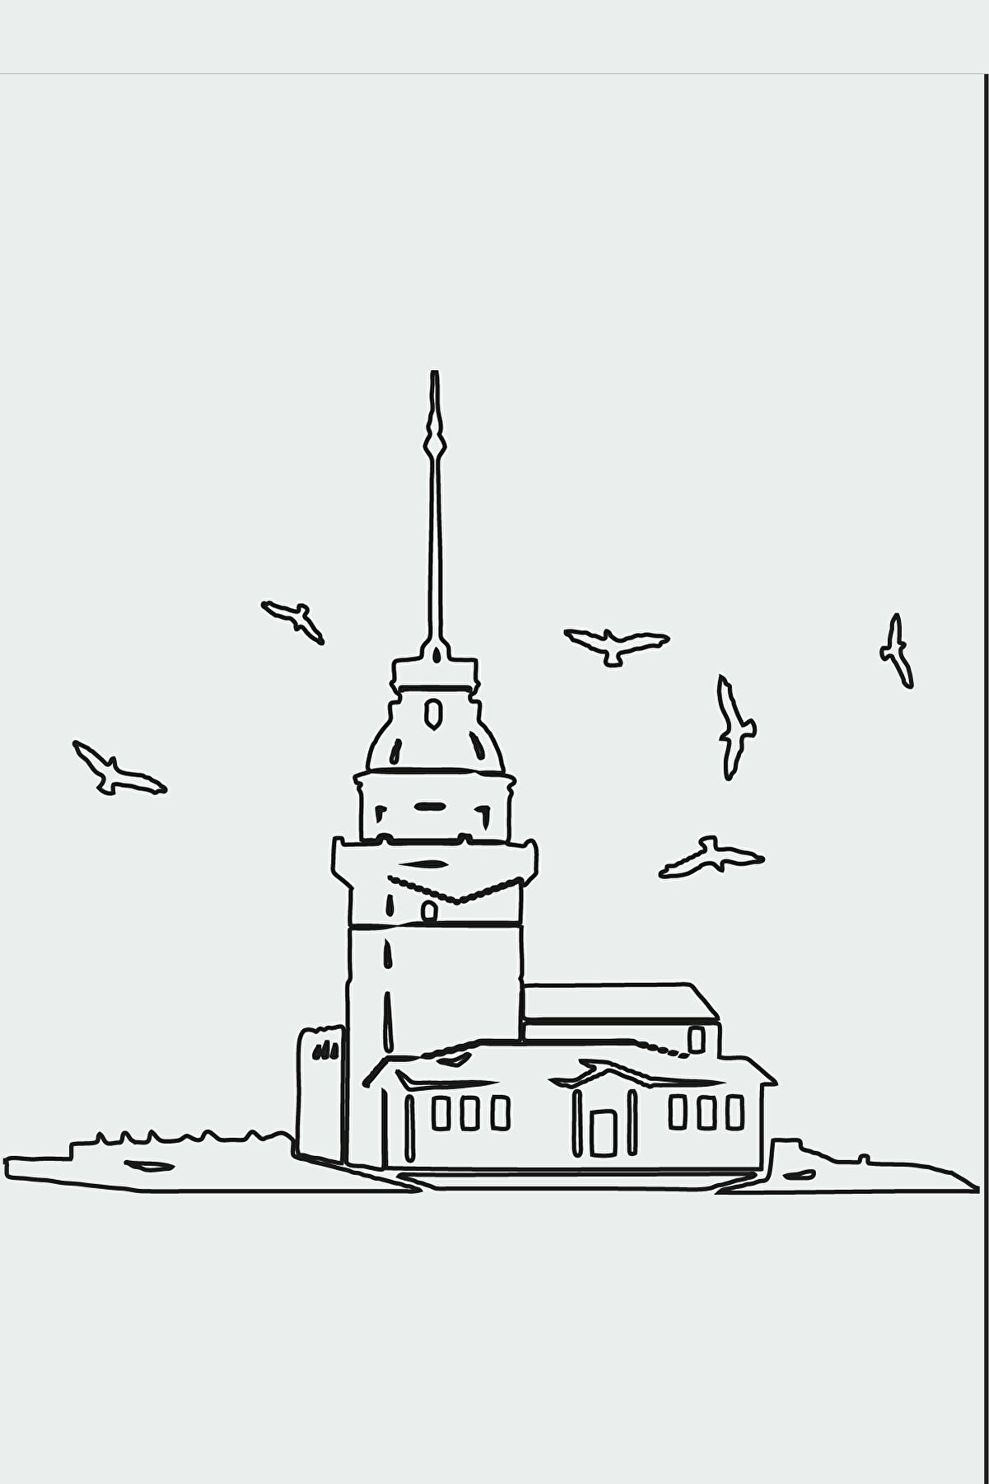

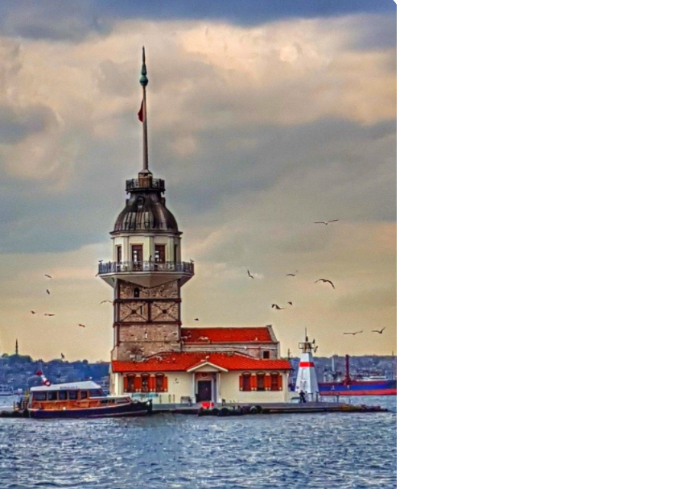

MAIDEN TOWER

The Maiden's Tower is on the waters of Üsküdar and it can be considered as the cornerstone of the Bosporus.The history of construction dates back to 341 BC, together with uncertainty of the exact date. The Maiden's Tower has been a subject of many myths in the history. It  has been called Damalis and Leandras in  the first times.The Tower has been used for many purposes such as lighthouse, strategic defense position, quarantine  hospital and radio station. Today, it will be used as a restaurant.

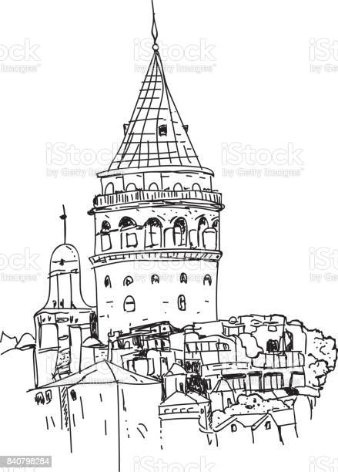

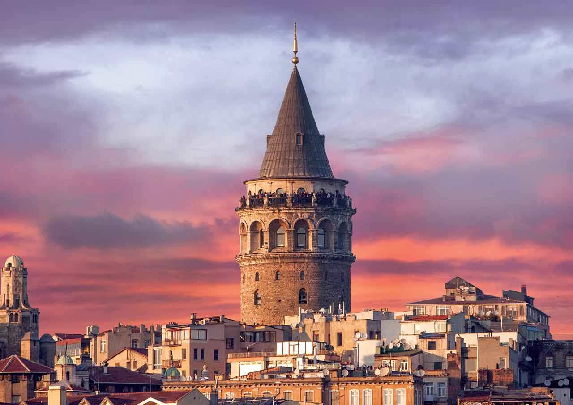

GALATA TOWER

The Galata Tower, Galata Kulesi in [Turkish](http://www.allaboutturkey.com/turkish.htm" \t "_blank), is one of the highest and oldest towers of Istanbul. 63 meter (206 feet) high tower provides a panoramic view of the old town. It was built in the 14th century by the Genoese colony as part of the defense wall surrounding their district at [Galata](http://www.greatistanbul.com/galata.html) directly opposite ancient Constantinopolis. They called the tower as "Christea Turris", or "Tower of Christ". The Genoese were involved in trade with the [Byzantines](http://www.allaboutturkey.com/byzantine.htm" \t "_blank) and the tower was used for the surveillance of the Harbor in the [Golden Horn](http://www.greatistanbul.com/golden_horn.html). After the [conquest of Constantinople](http://www.greatistanbul.com/conquest.html) by [Mehmet II](http://www.allaboutturkey.com/mehmet2.htm), it served to detect fires in the city.  
  
Hezarfen Ahmet Celebi was the first flying [Turk](http://www.allaboutturkey.com/origin.htm" \t "_blank) during the [Ottoman Empire](http://www.allaboutturkey.com/ottoman.htm" \t "_blank) of the 17th century. He copied bird wings and studied air flows, than jumping from the Galata Tower he overflew the [Bosphorus](http://www.greatistanbul.com/bosphorus.html) and landed at [Uskudar district](http://www.greatistanbul.com/uskudar.html) on the Asian side, around 6 kilometers (4 miles) in distance.

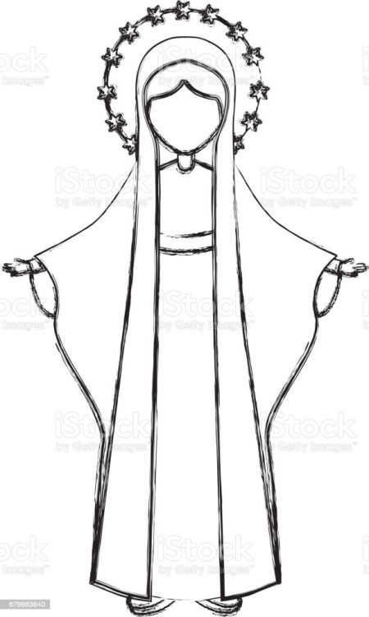

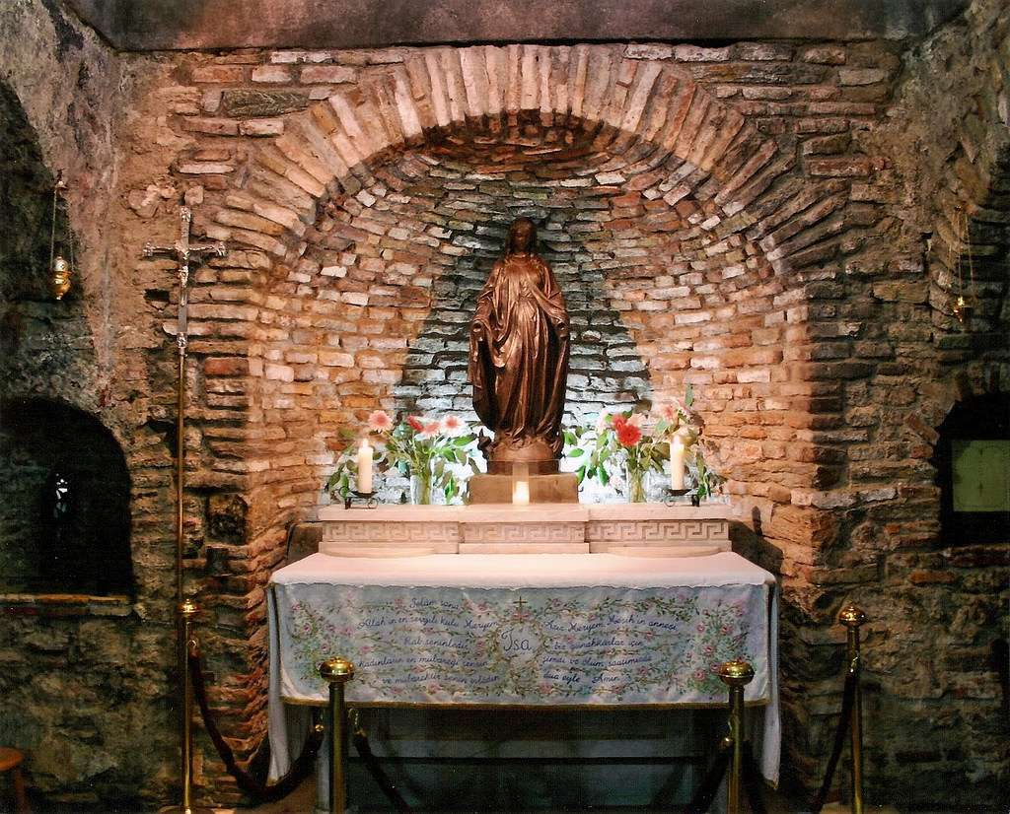

MOTHER MARY’S HOME

Mother Mary's Home, İzmir Mary's mother in Bülbüldağı in Selçuk, St. Mary's last years. The church believed to have been with Jean (John). It is a place of pilgrimage for Christians.  
  
It is thought that Mary's tomb is also in Bülbüldağı.  
  
There is a small Byzantine Church in the ruins of the Virgin Mary Main, which passed by the upper door of the ancient city of Ephesus. Here it is believed that Mary, the mother of the Prophet, lived and died. In addition to Christians, Muslims are regarded as sacred and visited, illness healing is sought, and vows are devoted. The Church's acquisition of the Mother Mary title may also be due to the fact that the Ecumenical Parliament assembled in Ephesus in 431 decided that Mary gave birth to Jesus as the Son of God.

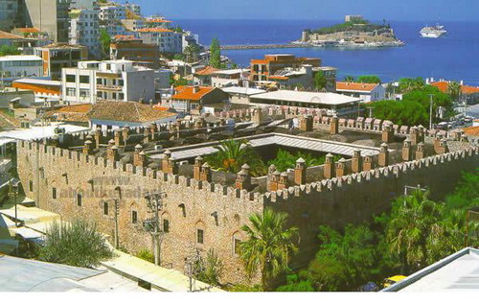

KUSADASI CARAVANSERAI

The commissioner of the complex was [Öküz Mehmet Pasha](https://en.wikipedia.org/wiki/%C3%96k%C3%BCz_Mehmet_Pasha) (died in 1619), a [grand vizier](https://en.wikipedia.org/wiki/Grand_vizier" \o "Grand vizier) of the [Ottoman Empire](https://en.wikipedia.org/wiki/Ottoman_Empire" \o "Ottoman Empire). (There is another caravanserai bearing his name in [Kuşadası](https://en.wikipedia.org/wiki/Ku%C5%9Fadas%C4%B1)) During his campaign to [Safavid dynasty](https://en.wikipedia.org/wiki/Safavid_dynasty" \o "Safavid dynasty) of [Persia](https://en.wikipedia.org/wiki/Persian_Empire" \o "Persian Empire) (modern Iran) in 1615, he decided to spend the winter in Ulukışla. But he was unable to find adequate barracks for his soldiers and he had to distribute the troops to nearby towns. To solve the problem for the future campaigns he had the complex built in 1616. According to another theory about the origin of the complex, Ulukışla was the birth place of Öküz Mehmet Pasha and he tried to rebuild his home town. The complex underwent a renovation in 1753.[[2]](https://en.wikipedia.org/wiki/%C3%96k%C3%BCz_Mehmet_Pasha_Complex#cite_note-NKT-2) In 2011 it was restored by the [Directorate of Foundations](https://en.wikipedia.org/wiki/Directorate_General_of_Foundations_(Turkey)" \o "Directorate General of Foundations (Turkey)).[[3]](https://en.wikipedia.org/wiki/%C3%96k%C3%BCz_Mehmet_Pasha_Complex#cite_note-Haberler-3) Presently the complex is used as a market place . Both the governorship and the municipality have offices in the building.

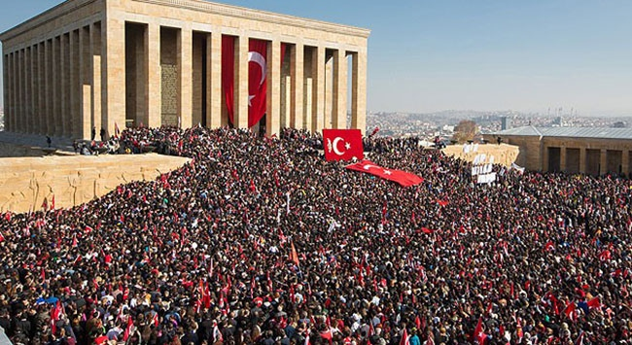

ANITKABIR

Mausoleum ANITKABIR from ATATURK

Who is ATATURK

Independence War Period, represents the establishment of the Republic of Turkey. It is very valuable for the Turkish nation as it is a period when a country is free from enemy occupation. One of the first events in terms of the establishment of the Republic of Turkey Grand National Assembly of Turkey is founded on 23 April 1920. Mustafa Kemal Ataturk was appointed as the Speaker of the Assembly, and many decisions were passed, especially the new constitution.

The Turkish War of Independence officially started on May 15, 1919, after the Treaty of Sevres. According to the result of the Treaty of Sèvres, the states that won the First World War started to occupy the lands of the Ottoman Empire. The first to see these invasions as an irregular army; The militia forces known as Kuva-yi Milliye reacted. Then Turkey Grand National Assembly established a regular army with the decision and integrating these militias and the army has exited victorious in the war.

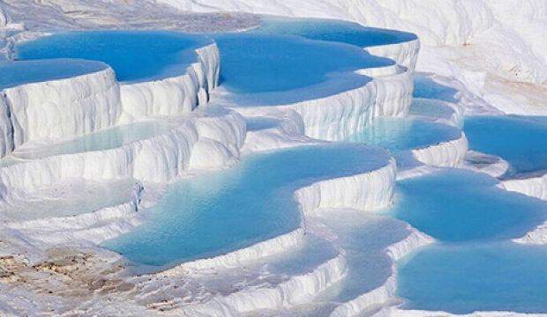

PAMUKKALE

" Pamukkale, which has been used as a spa since the second century BC, literally means “cotton castle” in Turkish.

The travertine features have their origins in the shifting of a fault in the valley of the Menderes river (between here and Denizli). As the fault shifted, very hot springs with a very high mineral content (notably chalk) arose at this location. Apart from the slightly radioactive minerals, the calcium and hydrogen carbonate react to create calcium carbonate (also known as travertine) and limestone. This is what gives Pamukkale its whiteness and created the pools. The Travertines of Pamukkale are a set of bizarre calcium cliff bathing pools overlooking the town of Pamukkale."



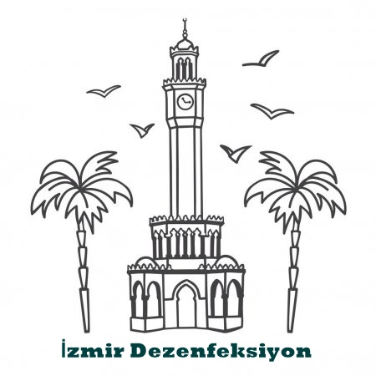

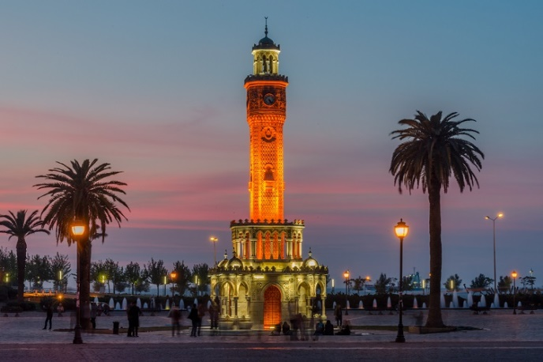

İZMİR CLOCK TOWER

Izmir Clock Tower (Turkish: İzmir Saat Kulesi) is a historic clock tower located at the Konak Square in Konak district of İzmir, Turkey. The clock tower was designed by the Levantine French architect Raymond Charles Père and built in 1901 to commemorate the 25th anniversary of Abdülhamid II's accession to the throne (reigned 1876–1909). The clock itself was a gift from German Emperor Wilhelm II (reigned 1888–1918). It is decorated in an elaborate Ottoman architecture style. The tower, which has an iron and lead skeleton, is 25 m (82 ft) high and features four fountains (şadırvan), which are placed around the base in a circular pattern. The columns are inspired by Moorish themes. The clock tower was depicted on the reverse of the Turkish 500 lira banknotes of 1983-1989.[1] In the former Balkan provinces of the Ottoman Empire, particularly in present-day Serbian, Bosnian and Montenegrin towns such as Belgrade, Prijepolje, Sarajevo, Banja Luka, Gradačac and Stara Varoš, similar Ottoman era clock towers still exist and are called Sahat Kula (derived from the Turkish words Saat Kulesi, meaning Clock Tower.)