EUROPE’S GREATEST MINDS. INVENTORS AND DISCOVERERS

LESSON PLAN

Topic: They Changed Europe - European Inventors and Discoverers

Overview
Without inventions and discoveries it would be impossible to live a modern lifestyle. The man has been using nature, taming it and giving it new purposes for centuries.

Objective
Students will:
- Get to know some European inventors and discoverers
- Learn about their inventions and discoveries and how they were used in various branches of science and daily life
- Find out some fun facts on famous inventors and discoverers
- Explore the influence of inventions and discoveries on human live over the centuries.

Materials
- tablets or smartphones for students (also with the internet access
- worksheets,
- pictures of famous inventors and discoverers together with QR codes.
Step 1 – INTRODUCTION
- Students get wordsearch puzzles and solve them.
- Brainstorming: What is a discovery? What is an invention?
- Discussion: how do discoveries and inventions influence our lives?
- Brainstorming: which inventors and discoverers do you know?
Step 2 – PRESENTATION
Students get worksheets with the pictures presenting different European discoverers and inventors and the QR codes. Their task is to:

- Scan the QR code and read about the inventor / discoverer
- Cut out the portraits, glue them onto the worksheet in chronological order and complete the table.
Step 3 – CONSOLIDATION
Presentation of the discoverers and inventors – putting pictures and information onto a big poster.
Step 4 – EVALUATION
Wordsearch for the names of inventors and discoverers.
Author: Kornelia Magiera
WORKSHEET 1
portraits of inventors and discoverers + QR codes

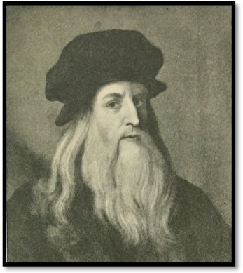
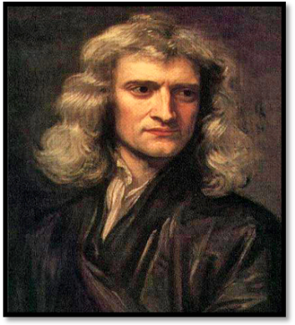
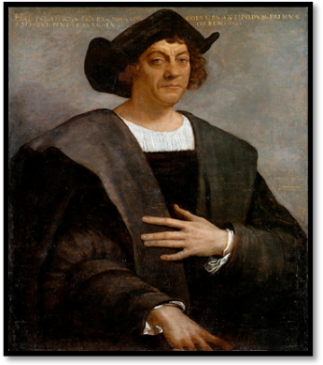




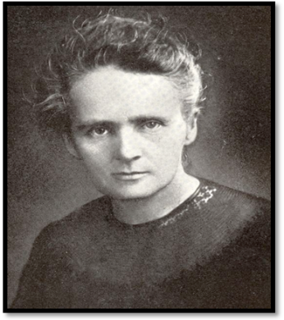
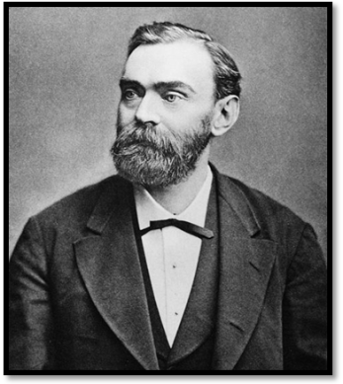
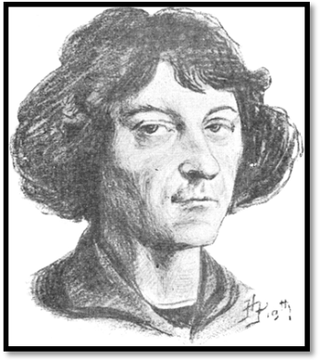





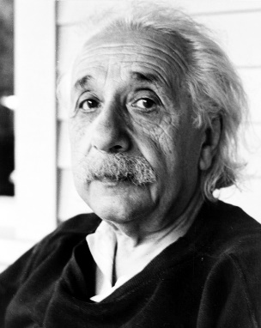
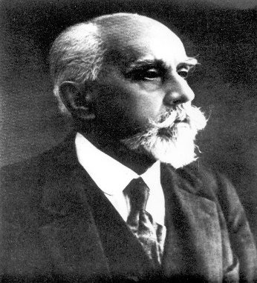
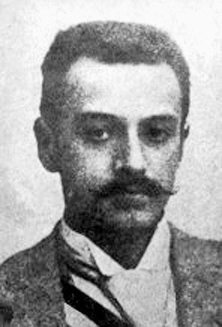





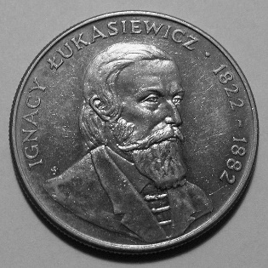



https://pl.wikipedia.org/wiki/Plik:Portrait_of_a_Man,_Said_to_be_Christopher_Columbus.jpg
https://ciekawostkihistoryczne.pl/leksykon/leonardo-da-vinci-1452-1519/
https://commons.wikimedia.org/wiki/File:GodfreyKneller-IsaacNewton-1689.jpg
https://commons.wikimedia.org/wiki/File:Album_pisarzy_polskich_page027__Miko%C5%82aj_Kopernik.png
https://pl.wikipedia.org/wiki/Plik:AlfredNobel2.jpg
https://pl.wikipedia.org/wiki/Plik:Marie_Curie_(1900).jpg
https://pl.m.wikipedia.org/wiki/Plik:Stefan_Drzewiecki.jpg
https://pl.wikipedia.org/wiki/Plik:Kazimierz_Pr%C3%B3szy%C5%84ski_1909.jpg
https://www.maxpixel.net/Man-Albert-Einstein-Physicist-E-Mc2-Scientist-401491
https://pl.wikipedia.org/wiki/Plik:Ignacy_%C5%81ukasiewicz_(coin).jpg

source: Wikipedia

WORKSHEET 2

Portrait | Name | Discovery / invention
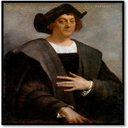
Portret
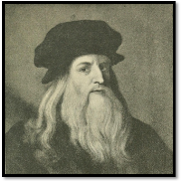
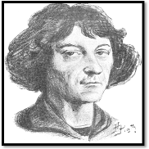
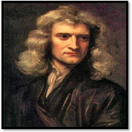
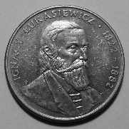
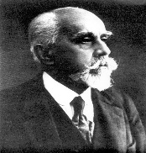
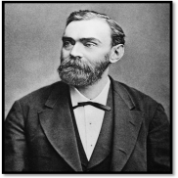
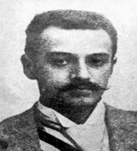
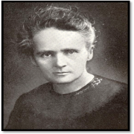
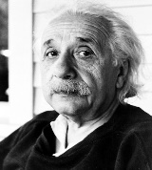
https://pl.wikipedia.org/wiki/Plik:Portrait_of_a_Man,_Said_to_be_Christopher_Columbus.jpg
https://ciekawostkihistoryczne.pl/leksykon/leonardo-da-vinci-1452-1519/
https://commons.wikimedia.org/wiki/File:GodfreyKneller-IsaacNewton-1689.jpg
https://commons.wikimedia.org/wiki/File:Album_pisarzy_polskich_page027__Miko%C5%82aj_Kopernik.png
https://pl.wikipedia.org/wiki/Plik:AlfredNobel2.jpg
https://pl.wikipedia.org/wiki/Plik:Marie_Curie_(1900).jpg
https://pl.m.wikipedia.org/wiki/Plik:Stefan_Drzewiecki.jpg
https://pl.wikipedia.org/wiki/Plik:Kazimierz_Pr%C3%B3szy%C5%84ski_1909.jpg
https://www.maxpixel.net/Man-Albert-Einstein-Physicist-E-Mc2-Scientist-401491
https://pl.wikipedia.org/wiki/Plik:Ignacy_%C5%81ukasiewicz_(coin).jpg

source: Wikipedia

WORKSHEET 2 - KEY

Portret | Nazwisko | Wynalazek/Odkrycie
Portret | Christopher Columbus  (1451 – 1506)  Italy | Discovered America
 | Leonardo da Vinci  (1452-1519)  Italy | Made a variety of inventions, such as hydraulic pumps, reversible crank mechanisms, finned mortar shells, a steam cannon etc.
 | Mikołaj Kopernik  (1473- 1543)  Poland | Stopped the Sun, moved the Earth
 | Isaac Newton  (1643 – 1727)  England | Discovered three rules of dynamics
 | Ignacy Łukasiewicz  (1822 – 1882)  Poland | Invented the oil lamp
 | Alfred Nobel  (1833 – 1896)  Sweden | Invented the dynamite  Funded the Prize for special achievements
 | Stefan Drzewiecki  (1844 – 1938)  Poland | Invented the speed registrator for trains,  dromograph – device to draw the route of a ship, a plane flight stabilizer, an aerodynamic tunnel etc.
 | Maria Skłodowska – Curie  (1867 – 1934)  Poland | Discovered Polonium and Radium  Exploted radioactivity
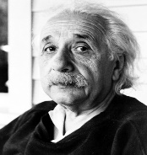 | Kazimierz Prószynski  (1875 – 1945)  Poland | Invented the first pleograph, the film camera
 | Albert Einstein  (1879 – 1955)  Germany | Developed the theory of relativity and put the foundations of modern physics
https://pl.wikipedia.org/wiki/Plik:Portrait_of_a_Man,_Said_to_be_Christopher_Columbus.jpg
https://ciekawostkihistoryczne.pl/leksykon/leonardo-da-vinci-1452-1519/
https://commons.wikimedia.org/wiki/File:GodfreyKneller-IsaacNewton-1689.jpg
https://commons.wikimedia.org/wiki/File:Album_pisarzy_polskich_page027__Miko%C5%82aj_Kopernik.png
https://pl.wikipedia.org/wiki/Plik:AlfredNobel2.jpg
https://pl.wikipedia.org/wiki/Plik:Marie_Curie_(1900).jpg
https://pl.m.wikipedia.org/wiki/Plik:Stefan_Drzewiecki.jpg
https://pl.wikipedia.org/wiki/Plik:Kazimierz_Pr%C3%B3szy%C5%84ski_1909.jpg
https://www.maxpixel.net/Man-Albert-Einstein-Physicist-E-Mc2-Scientist-401491
https://pl.wikipedia.org/wiki/Plik:Ignacy_%C5%81ukasiewicz_(coin).jpg

source: Wikipedia

WORKSHEET 3 – WORDSEARCH I

I. Colour every THIRD box – the letters in coloured boxes will show your solution:
A | B | I | K | G | N | L | M | V | K
I | E | R | W | N | P | Q | T | A | E
I | O | Z | O | F | E | N | T | K

II. Colour every FOURTH box – the letters in coloured boxes will show your solution:
H | K | O | D | B | I | K | I | K | T
R | S | A | Y | C | Y | C | O | A | O
M | O | Z | V | G | R | S | E | H | P
G | R | H | Q | V | Y | J | Z | G

WORKSHEET 4 – WORDSEARCH II

W | E | G | H | J | B | N | X | S | E | F | N | E | W | T | O | N
C | L | K | L | O | L | F | H | U | S | P | Y | T | R | O | W | O
H | E | C | O | P | E | R | N | I | K | W | D | F | O | K | J | B
A | O | O | P | E | O | Y | U | N | Ł | K | L | O | SH | F | N | E
Ł | N | L | Q | R | N | K | L | O | O | G | Q | P | E | B | B | L
U | A | U | H | J | A | X | D | H | D | E | H | J | B | C | F | T
K | R | M | P | E | R | Q | P | E | O | W | C | B | N | X | P | H
A | T | B | Q | P | D | R | Z | E | W | I | E | C | K | I | R | J
S | O | U | D | H | O | A | Q | P | S | F | P | E |  | P | Ó | S
  Q | P
I | SH | S | P | E | D | S | H | J | K | Y | G | P | E | L | S | O
E | E | F | R | T | A | Y | U | N | A | N | X | S | E | U | Z | SH
W | B | D | G | T | V | K | L | O | C | P | Y | T | R | M | Y | E
I | H | G | P | E | I | S | Y | I | U | U | C | B | N | I | Ń | B
C | Z | C | B | N | N | D | H | K | R | J | H | J | T | E | S | C
Z | X | Q | P | A | C | X | D | H | I | K | F | A | W | R | K | F
X | M | K | L | O | I | C | B | N | E | I | N | S | T | E | I | N

WORKSHEET 3 – WORDSEARCH I – KEY

I. Colour every THIRD box – the letters in coloured boxes will show your solution:.
A | B | I | K | G | N | L | M | V | K
I | E | R | W | N | P | Q | T | A | E
I | O | Z | O | F | E | N | T | K

II. Colour every FOURTH box – the letters in coloured boxes will show your solution:
H | K | O | D | B | I | K | I | K | T
R | S | A | Y | Y | C | C | O | A | O
M | O | Z | V | G | R | S | E | H | P
G | R | H | Q | V | Y | J | Z | G

WORKSHEET 4 – WORDSEARCH II – KEY

W | E | G | H | J | B | N | X | S | E | F | N | E | W | T | O | N
C | L | K | L | O | L | F | H | U | S | P | Y | T | R | O | W | O
H | E | C | O | P | E | R | N | I | K | W | D | F | O | K | J | B
A | O | O | P | E | O | Y | U | N | Ł | K | L | O | SH | F | N | E
Ł | N | L | Q | R | N | K | L | O | O | G | Q | P | E | B | B | L
U | A | U | H | J | A | X | D | H | D | E | H | J | B | C | F | T
K | R | M | P | E | R | Q | P | E | O | W | C | B | N | X | P | H
A | T | B | Q | P | D | R | Z | E | W | I | E | C | K | I | R | J
S | O | U | D | H | O | A | Q | P | S | F | P | E |  | P | Ó | S
  Q | P
I | SH | S | P | E | D | S | H | J | K | Y | G | P | E | I | S | O
E | E | F | R | T | A | Y | U | N | A | N | X | S | E | U | Z | SH
W | B | D | G | T | V | K | L | O | C | P | Y | T | R | S | Y | E
I | H | G | P | E | I | S | Y | I | U | U | C | B | N | I | Ń | B
C | Z | C | B | N | N | D | H | K | R | J | H | J | T | G | S | C
Z | X | Q | P | A | C | X | D | H | I | K | F | A | W | R | K | F
X | M | K | L | O | I | C | B | N | E | I | N | S | T | E | I | N

