EUROPE’S GREATEST MINDS. EUROPEAN WOMEN IN SCIENCE.

LESSON PLAN

Topic: They led the way: Europe’s pioneer female scientists.

Overview
Women in science is not a topic taught worldwide and in many cases if asked to name famous scientists one will easily recall men’s names, but will at the same time find it very hard to name any famous women scientists. Of course there are many reasons for this – the major one being a very limited access to higher education for women in the past and the historical fact of imposing on the women the traditional role of wives and mothers while at the same time denying them the right to develop their abilities and to pursue their scientific ambitions. This is why the women who managed to break through and achieve the highest academic success despite being stuck in these oppressive societies of the past deserve to be taught about and remembered.
We have decided to use Maria Skłodowska-Curie as a symbolic figure speaking for all women who had to struggle all their lives with the injustice and narrow-mindedness in order to follow their dream.

Objective
Students will:
- Learn about some of the famous European women scientists;
- Have a chance to ponder on the historical differences in education possibilities offered to
women and to men;
- Appreciate the importance of perseverance and ambition in achieving one’s goals despite
disadvantageous circumstances;
- Get involved in the discussion on equal opportunities.

Materials
- an overhead projector,
- laptop or computer with the internet access,
- tablets or smartphones for students (also with the internet access),
- worksheets.

Step 1 – INTRODUCTION
- Ask the students to name as many famous scientists as they can remember. Write the names on the board – use different colours for men and for women.
- Check how many names of each colour there are. Discuss the results with the students. Why are there so few women in the group? Encourage students to give some more women’s names. Add them to the list (if any are given).
- Check if the students know the name of Marie Curie. Tell them that they are going to watch a short film, shot in 2015 by students of the Polish WSE school for the purposes of a Comenius project. Ask the students to pay attention to details, as they are going to complete a worksheet after watching. The film is shot in Polish with English subtitles.

Step 2 – PRESENTATION

a. Play the film: https://www.youtube.com/watch?v=2VjocLcqCIU
b. Distribute worksheet 1 and allow students two minutes to talk in pairs.
c. Check the answers together.
d. Ask the students if they think there were other women who had to elbow their way to success in science.
e. Distribute worksheet 2 and ask students to work in pairs, trying to match the names and portraits to disciplines and achievements. Tell them to also look at fashion, hairstyles and dates while matching the names to the portraits. After ten minutes give out the key and ask the pairs to check their work, giving one point for each correct match. Who has scored the most points?

Step 3 – CONSOLIDATION
- Ask the students which scientist has made the biggest impression on them. Why?
- Ask the students to go online and find at least five additional facts about this person’s life, work and achievements.
- Share the discovered facts with the rest of class.

Step 4 – EVALUATION
- Distribute evaluation worksheets (worksheet 3) that will help the children remember the names of some of the famous female scientists of Europe:
- a wordsearch puzzle
- a crosswords puzzle.
- Check which group has scored more throughout the lesson. The maximum score is 46 points.

Author:
Anna Milerska

WORKSHEET 1 score …. / 10 points
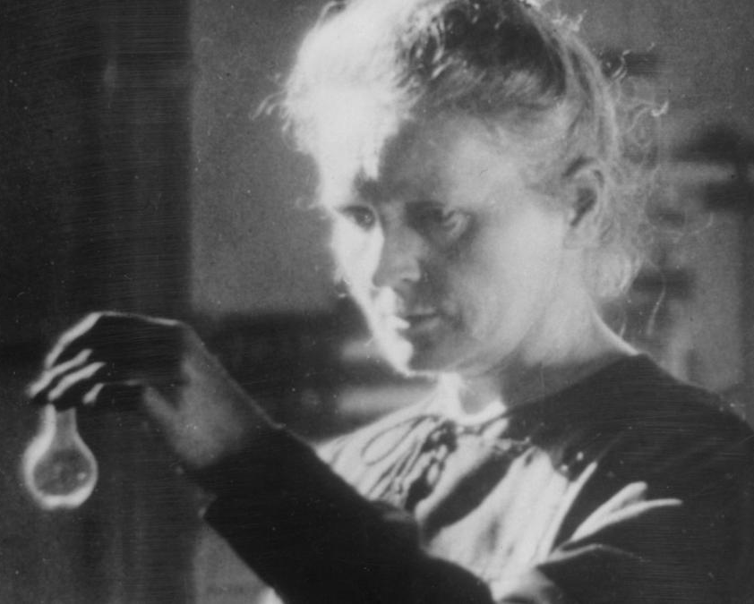

- You have just seen the film “Maria” shot by the
students of 34 Nicholas Copernicus Primary School
in Katowice in 2015. The main character of the film
is a renowned scientist, Maria Skłodowska-Curie.

- Now, choose the correct answer:
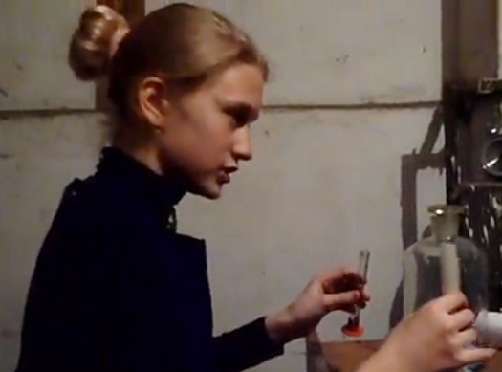
- Maria’s home town was
a) Paris b) London c) Warsaw
- Maria’s surviving siblings included:
a) one brother and one sister
b) two brothers and one sister
c) two sisters and one brother
- Maria’s father wanted her to study
a) maths b) physics c) chemistry
- Maria decided to go to study in
a) Paris b) London c) Warsaw
- What results did Maria get while at university?
a) excellent b) good c) poor
- What didn’t Maria have to struggle with while at university?
- poverty b) prejudice c) illness
- What was Maria’s husband’s name?
- Thomas b) Pierre c) Jean
- Which is not an element discovered by Maria?
a) helium b) polonium c) radium
- Which phenomenon was of special interest to her?
- radioactivity b) crystallisation c) osmosis
- Which statement is not true of Maria?
- she was the first woman to receive the Nobel Prize
- she was the first scientist to receive the Nobel Prize twice
- she was the only person to receive the Nobel Prizes in different sciences
- she was the first woman scientist
WORKSHEET 1 - KEY
- You have just seen the film “Maria” shot by the
students of 34 Nicholas Copernicus Primary School
in Katowice in 2015. The main character of the film
is a renowned scientist, Maria Skłodowska-Curie.

- Now, choose the correct answer:
- Maria’s home town was
a) Paris b) London c) Warsaw
- Maria’s surviving siblings included:
a) one brother and one sister
b) two brothers and one sister
c) two sisters and one brother
- Maria’s father wanted her to study
a) maths b) physics c) chemistry
- Maria decided to go to study in
a) Paris b) London c) Warsaw
- What results did Maria get while at university?
a) excellent b) good c) poor
- What didn’t Maria have to struggle with while at university?
- poverty b) prejudice c) illness
- What was Maria’s husband’s name?
- Thomas b) Pierre c) Jean
- Which is not an element discovered by Maria?
a) helium b) polonium c) radium
- Which phenomenon was of special interest to her?
- radioactivity b) crystallisation c) osmosis
- Which statement is not true of Maria?
- she was the first woman to receive the Nobel Prize
- she was the first scientist to receive the Nobel Prize twice
- she was the only person to receive the Nobel Prizes in different sciences
- she was the first woman scientist

WORKSHEET 2 score: …... / 21 points
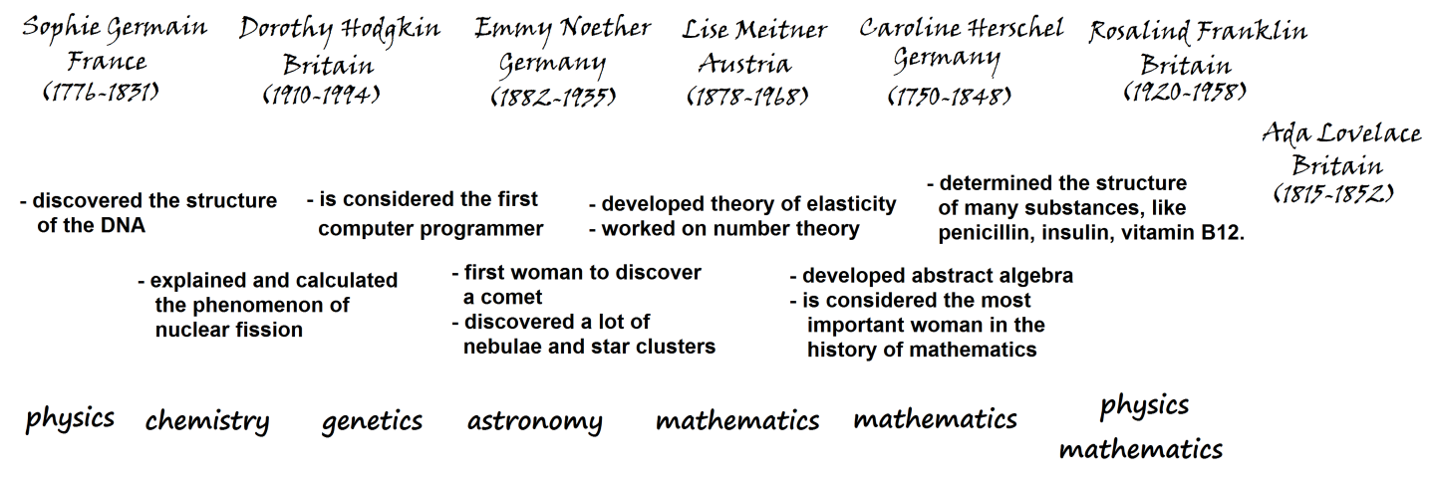
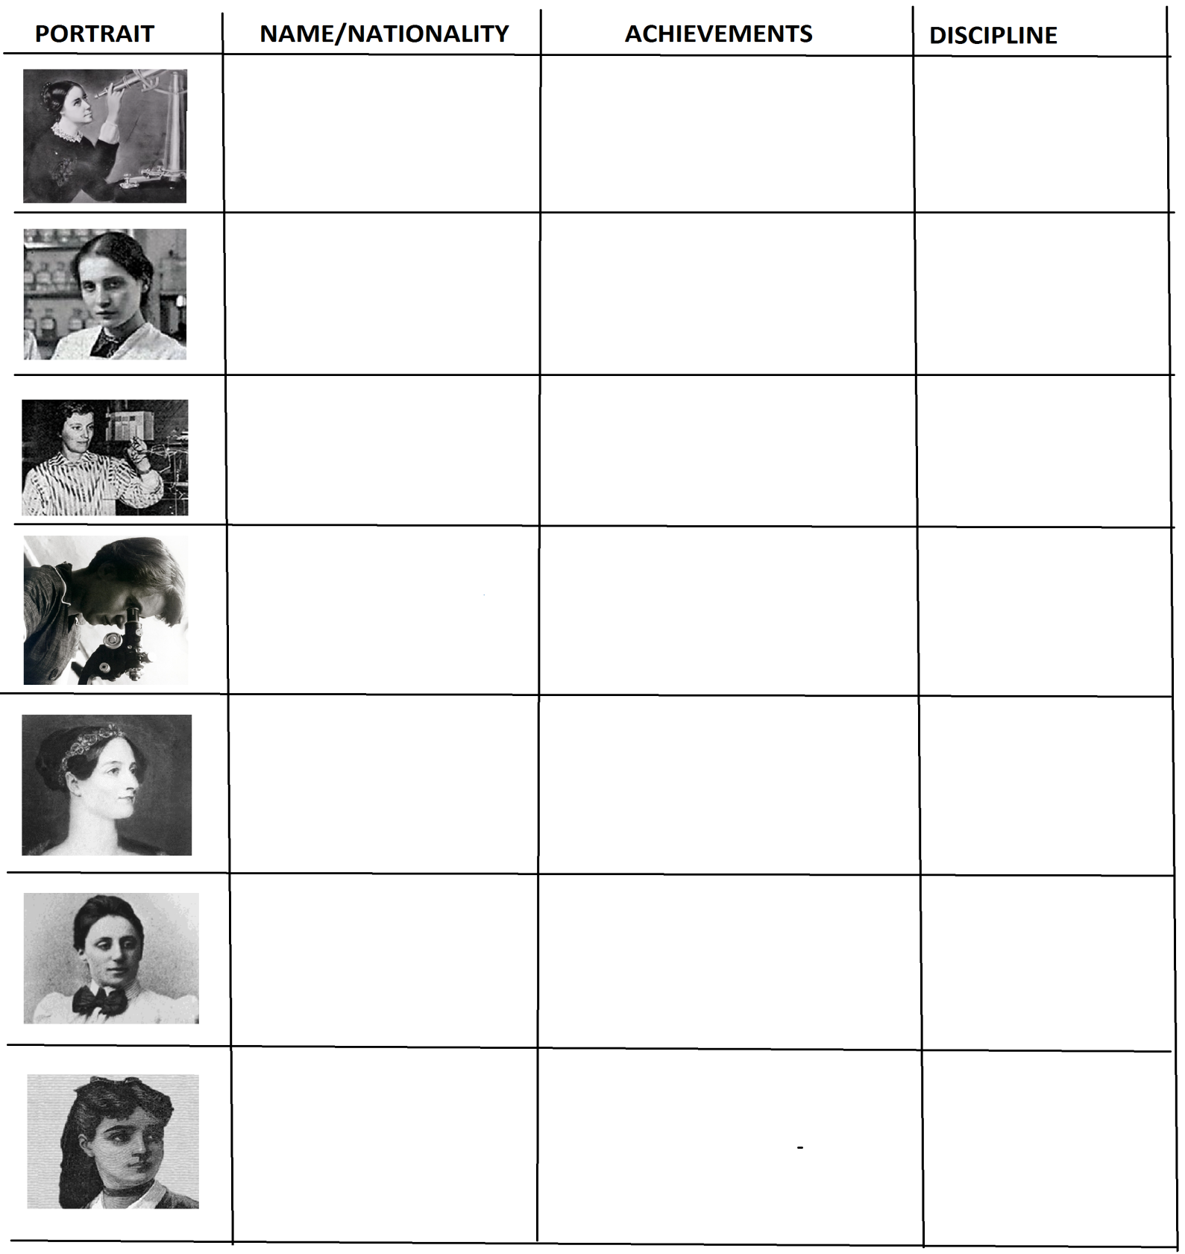
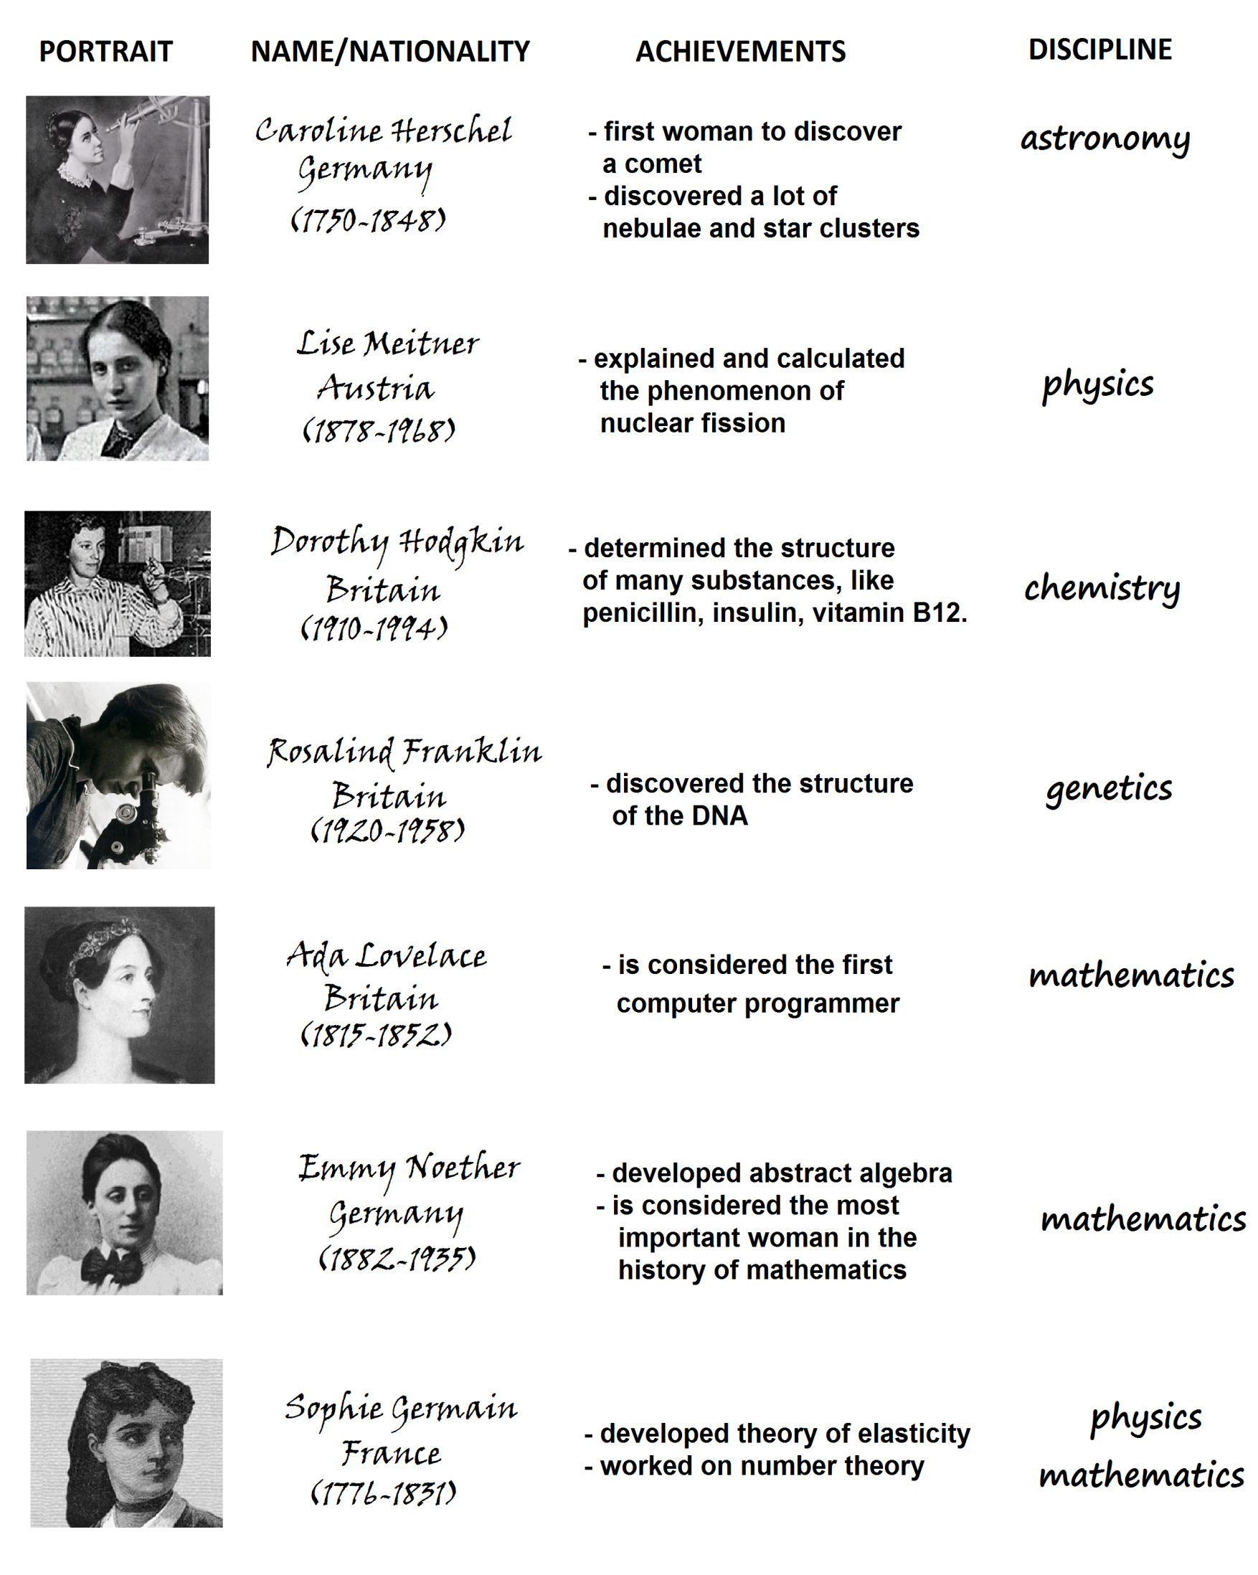
WORKSHEET 2 – KEY
WORKSHEET 3 score: …… / 15 points
How many of the eight European women scientists’ names can you find in this worksheet? Only surnames are included. Then, do the crossword puzzle.
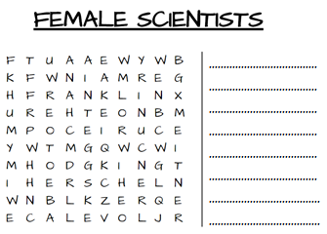
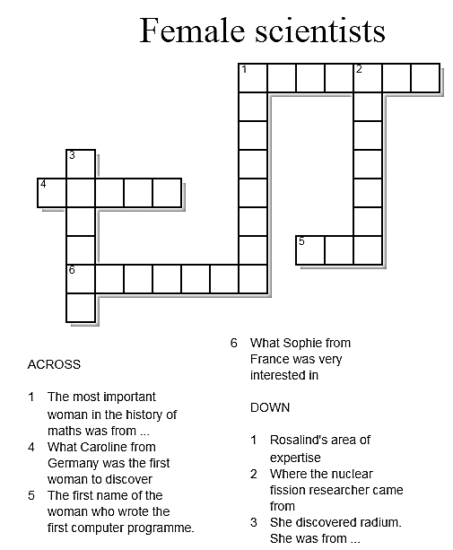
WORKSHEET 3 - KEY
How many of the eight European women scientists’ names can you find in this worksheet? Only surnames are included. Then, do the crossword puzzle.

