EUROPE’S GREATEST MINDS. INVENTIONS
LESSON PLAN

Topic: Invented inEurope

Overview:

Do we ever wonder who and when invented objects we use on a daily basis? Which of the inventions were born here and who is behind them?

Objectives:
Students
- Will find out which of the inventions they use were born in Europe
- Will learn the stories behind some of these inventions
- Will develop their map skills
- Will improve their web search abilities
- Will practice selecting information by means of mind-mapping.

Materials:
- Overhead projector, screen
- Laptop or computer with the Internet access
- Tablets or smartphones for students, also with Internet access
- Cut-out worksheets (1 per class, divided equally among groups)
- blank A3 sheets for mind maps (one per group)
- Envelopes (2 per group)
- Paper map, printed out and glued together
Step 1 – INTRODUCTION:
- https://ed.ted.com/lessons/how-braille-was-invented-moments-of-vision-9-jessica-oreck
The introduction to the Lesson will be made by watching a video on creating the Braille alphabet. Ask the students what an inventions is. Divide the students into two teams, put them in a row facing the blackboard. Prepare the timer (online classtimer, hourglass etc.). Set the time to three minutes and ask the students to come up to the board one by one and write names of inventions which according to them were born In Europe. Leave the list on the board – you will use it again at the end of the lesson.

Step 2 – GROUPWORK:
- Divide the students into groups of 4-5. Each group gets two envelopes, one with names of inventors and one with pictures of inventions (there are twenty altogether, each group should get an equal number of pieces to look up). Students use tables and smartphones to look up information on the inventors and what they created. They find pictures corresponding to the inventions of people they have in their envelopes. They find the places where the inventors lived on the map and glue the pictures and names there.
(The map can be generated and printed from here: https://www.nationalgeographic.org/maps/europe-mapmaker-kit/, or you can use a ready pattern, eg this one: https://media.nationalgeographic.org/assets/file/europe-tabletopmap-part2.pdf). The map may be coloured, written and drawn on etc.
- Each group chooses one inventor from their envelope and make a mind-map about him/her. Here’s an example of what a mind map looks like:
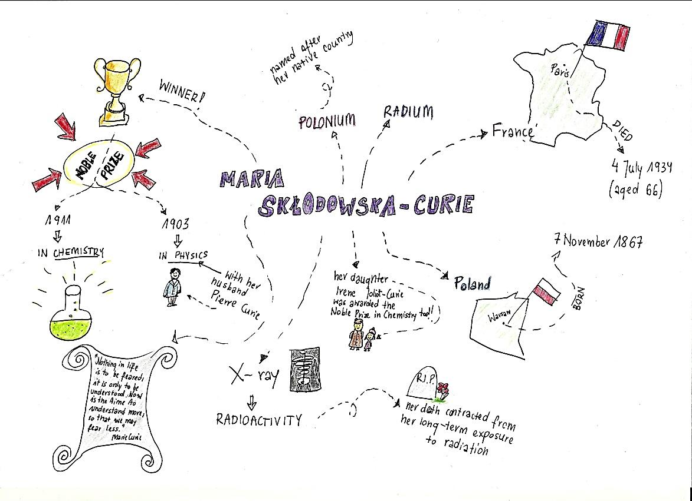
Step 3 – CONSOLIDATION
Groups come up to the big map and tell the class about their inventions and discuss the mind maps. The mind maps stay on the board. It’s the time of information sharing.
Step 4 – EVALUATION
- Do the task from the introduction step again. How many European inventions and inventors can students write down on the board now?
- Compare the correct information from the beginning and end of the Lesson. Encourage students to share which information they found most interesting / surprising etc.
Author: Magdalena Dela
WORKSHEET – CUT IT OUT AND PUT IN ENVELOPES
Jan Gutenberg | 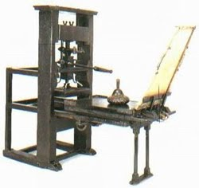
Zacharias Janssen | 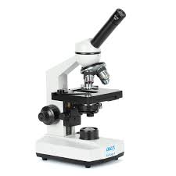
John Spilsbury | 
Ignacy Łukasiewicz | 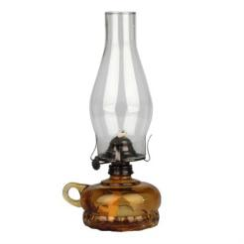
Werner Siemens | 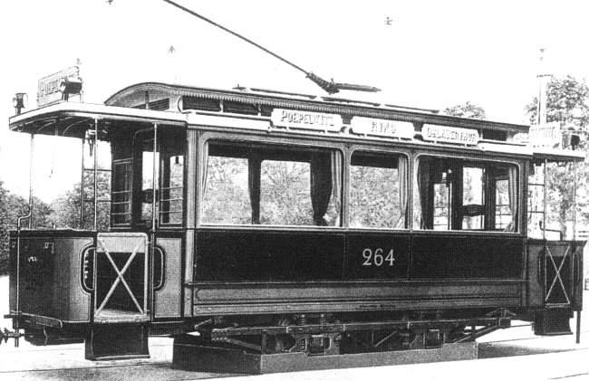
Alfred Nobel | 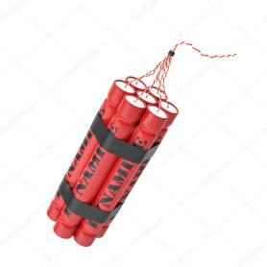
Alexander Graham Bell | 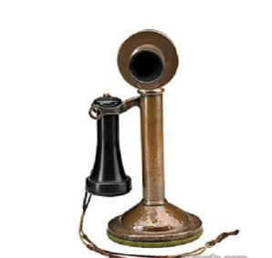
Carl Friedrich Benz | 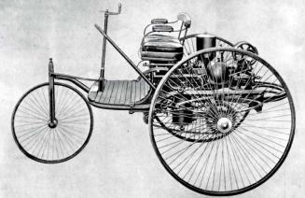
The Lumiere Brothers | 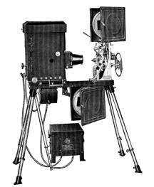
Guglielmo Marconi | 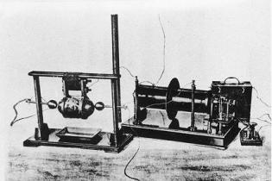
Józef Kosacki, Andrzej Garboś | 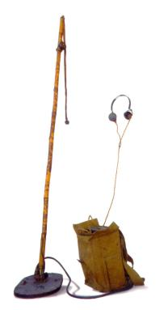
Leonardo da Vinci | 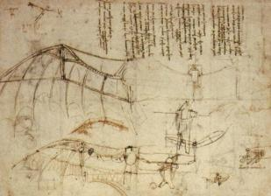
Iwan Puluj | 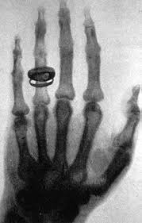
Alexander Fleming | 
James Watt | 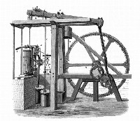
Enric Bernat | 
Erno Rubik | 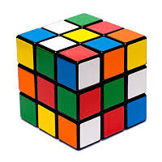
Louis Renault | 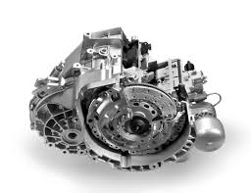
Edward Jenner | 
Jan Szczepanik  and Kazimierz Żegleń | 

