EUROPE’S GREATEST MINDS. NICHOLAS COPERNICUS

LESSON PLAN

Topic: „Stopped the Sun, Moved the Earth”
Nicholas Copernicus – More Than Just a Great Astronomer.

Overview
Nicholas Copernicus is one of the representatives of the era of Renaissance. Well-educated, he held a high position in the Church hierarchy, but was also very active in the fields of medicine, law or military strategy. His best known and most important achievements are connected with geometry, economy and astronomy. He never ceased to look for the answer to the question of the essence of the Universe. Having conducted a series of research and observations, he published his most important work “De revolutionibus orbium coelestium” (On the Revolutions of the Celestial Spheres), which popularized the heliocentric theory and made Copernicus the man who “stopped the Sun and moved the Earth”, thus denying the medieval perception of the Universe.

Objective
The students:
- Will learn about Nicholas Copernicus as an outstanding personality of the European Renaissance, whose scientific achievement revolutionized the views on the Universe;
- Will find out the basic facts from his life and discoveries which are still important for us today;
- Will use the ICT tools in order to obtain, select and order information.

Materials
- Overhead projector, screen
- loudspeakers
- laptop or computer with Internet access
- tablets with QR reader apps
- worksheets
Step 1: INTRODUCTION
A conversation on famous Europeans:
- Which famous Europeans do you know?
- What made these people famous?
- What were their areas of expertise?
- What do we owe them today?
- Do you know any people from the time of Renaissance? What are they known for?
Step 2: PRESENTATION
- Introducing the topic of the Lesson:
Today we are going to meet one of the greatest Renaissance minds in Europe, whose discoveries changed the way people perceived the Universe.
- If time allows, you can play a fragment of a video on Renaissance:
The subtitled film lasts 8 minutes and 25 seconds – show the first two minutes: https://www.youtube.com/watch?v=xf2G2Il8crw
- Students scan the QR code which takes them to an app where they make a portrait of Nicholas Copernicus: https://www.jigsawplanet.com/?rc=play&pid=1efcb349a4c9
- Discuss with the students: Whose portrait is this? What is he famous for?
- Tell the students that the painter was Jan Matejko and the painting is called „Astronomer Copernicus, or Conversations with God”. It shows Copernicus during his observations of the sky from his private tower on a cathedral hill in Frombork.
- Present a short biographical film about Copernicus. Choose one option:
- Short film, no subtitles ( 2:41 min.): https://www.youtube.com/watch?v=M0p6NKANE08
- Long film, subtitled ( 28:50 min.): https://www.youtube.com/watch?v=E6_j8Xv2ae0
Step 3: GROUPWORK
- Divide the class into groups (no more than 4 students in a group)
- Each group gets a tablet and a worksheet.
Task 1
Students scan the QR code which takes them to the map of Europe where they visit places connected with the life of Copernicus and read information on his works and activities: https://www.thinglink.com/scene/1135238715753365507
Task 2
Students do the wordsearch – names of cities connected with the life of Copernicus. The solution: names of jobs Copernicus did.
Task 3
Students scan the QR codes and complete the table with information on the most important achievements of Copernicus.
Step 4: CONSOLIDATION
Students check their knowledge on Nicholas Copernicus, who was so much more than just a great astronomer, by doing the Kahoot quiz:
https://play.kahoot.it/#/k/62cb9da2-05c0-40f8-bd47-6aaa1be2ae4f
Author:
Ewa Kowalska

WORKSHEET

Presentation Task:
Scan the QR code and do the puzzle. You will get a portrait of a famous scientist of the era of Renaissance.
What was his name?
What was his area of expertise?


Task 1
Scan the code and explore the map of Europe. Find places connected with the life of Nicholas Copernicus and read the information on his life and work:

Task 2
Do the wordsearch – cross out the names of cities connected with the life of Copernicus. Then you will see your solution: names of jobs he did in his life.
a | s | t | r | o | n | o | m | e | r | p | a
d | o | v | a | d | o | c | t | o | r | f | r
o | m | b | o | r | k | t | r | a | n | s | l
a | t | o | r | t | o | r | u | ń | m | a | t
h | e | m | a | t | i | c | i | a | n | b | o
l | o | g | n | a | l | a | w | y | e | r | k
r | a | a | k | ó | w | e | c | o | n | o | m
i | s | t | f | e | r | r | a | r | a | a | s
t | r | o | l | o | g | e | r | o | l | s | z
t | y | n | s | t | r | a | t | e | g | i | s
t | l | i | d | z | b | a | r | k

Task 3
Complete the table with the most important achievements of Copernicus in three branches of science. Put in the appropriate letters and numbers:
AREA | ASTRONOMY | GEOMETRY | ECONOMY
theory
illustration

- Copernicus-Gresham law „Bad money drives out good”
- Heliocentric theory: „The Earth and other planets revolve around the Sun, which is the centre of the Solar System”
- The principle about a small circle which rotates inside a larger circle twice the diameter of the smaller circle. Rotations of the circles cause a point on the circumference of the smaller circle to oscillate back and forth in linear motion along a diameter of the larger circle.
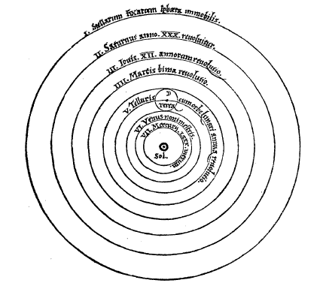
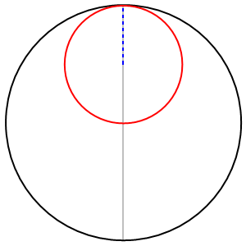
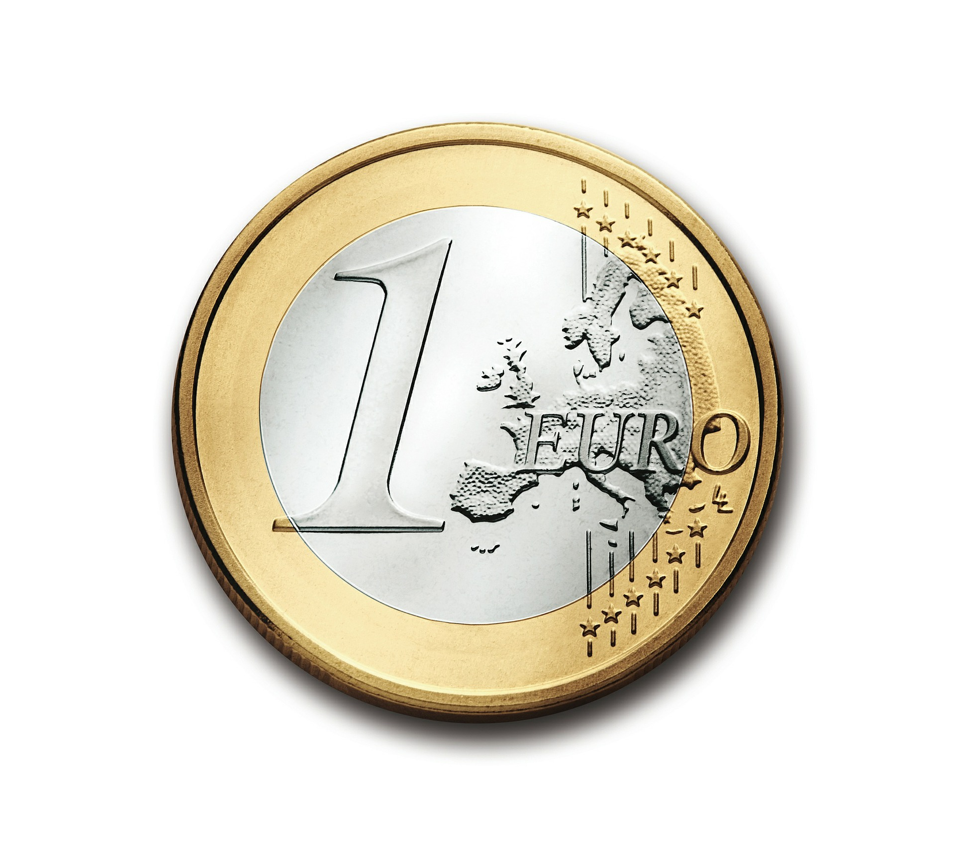
A. B. C.
- Scan the QR codes and check your answers:




Task 4
Now it’s time to play a Kahoot quiz in order to check how much you remember about Nicholas Copernicus.

WORKSHEET – KEY
Presentation task:
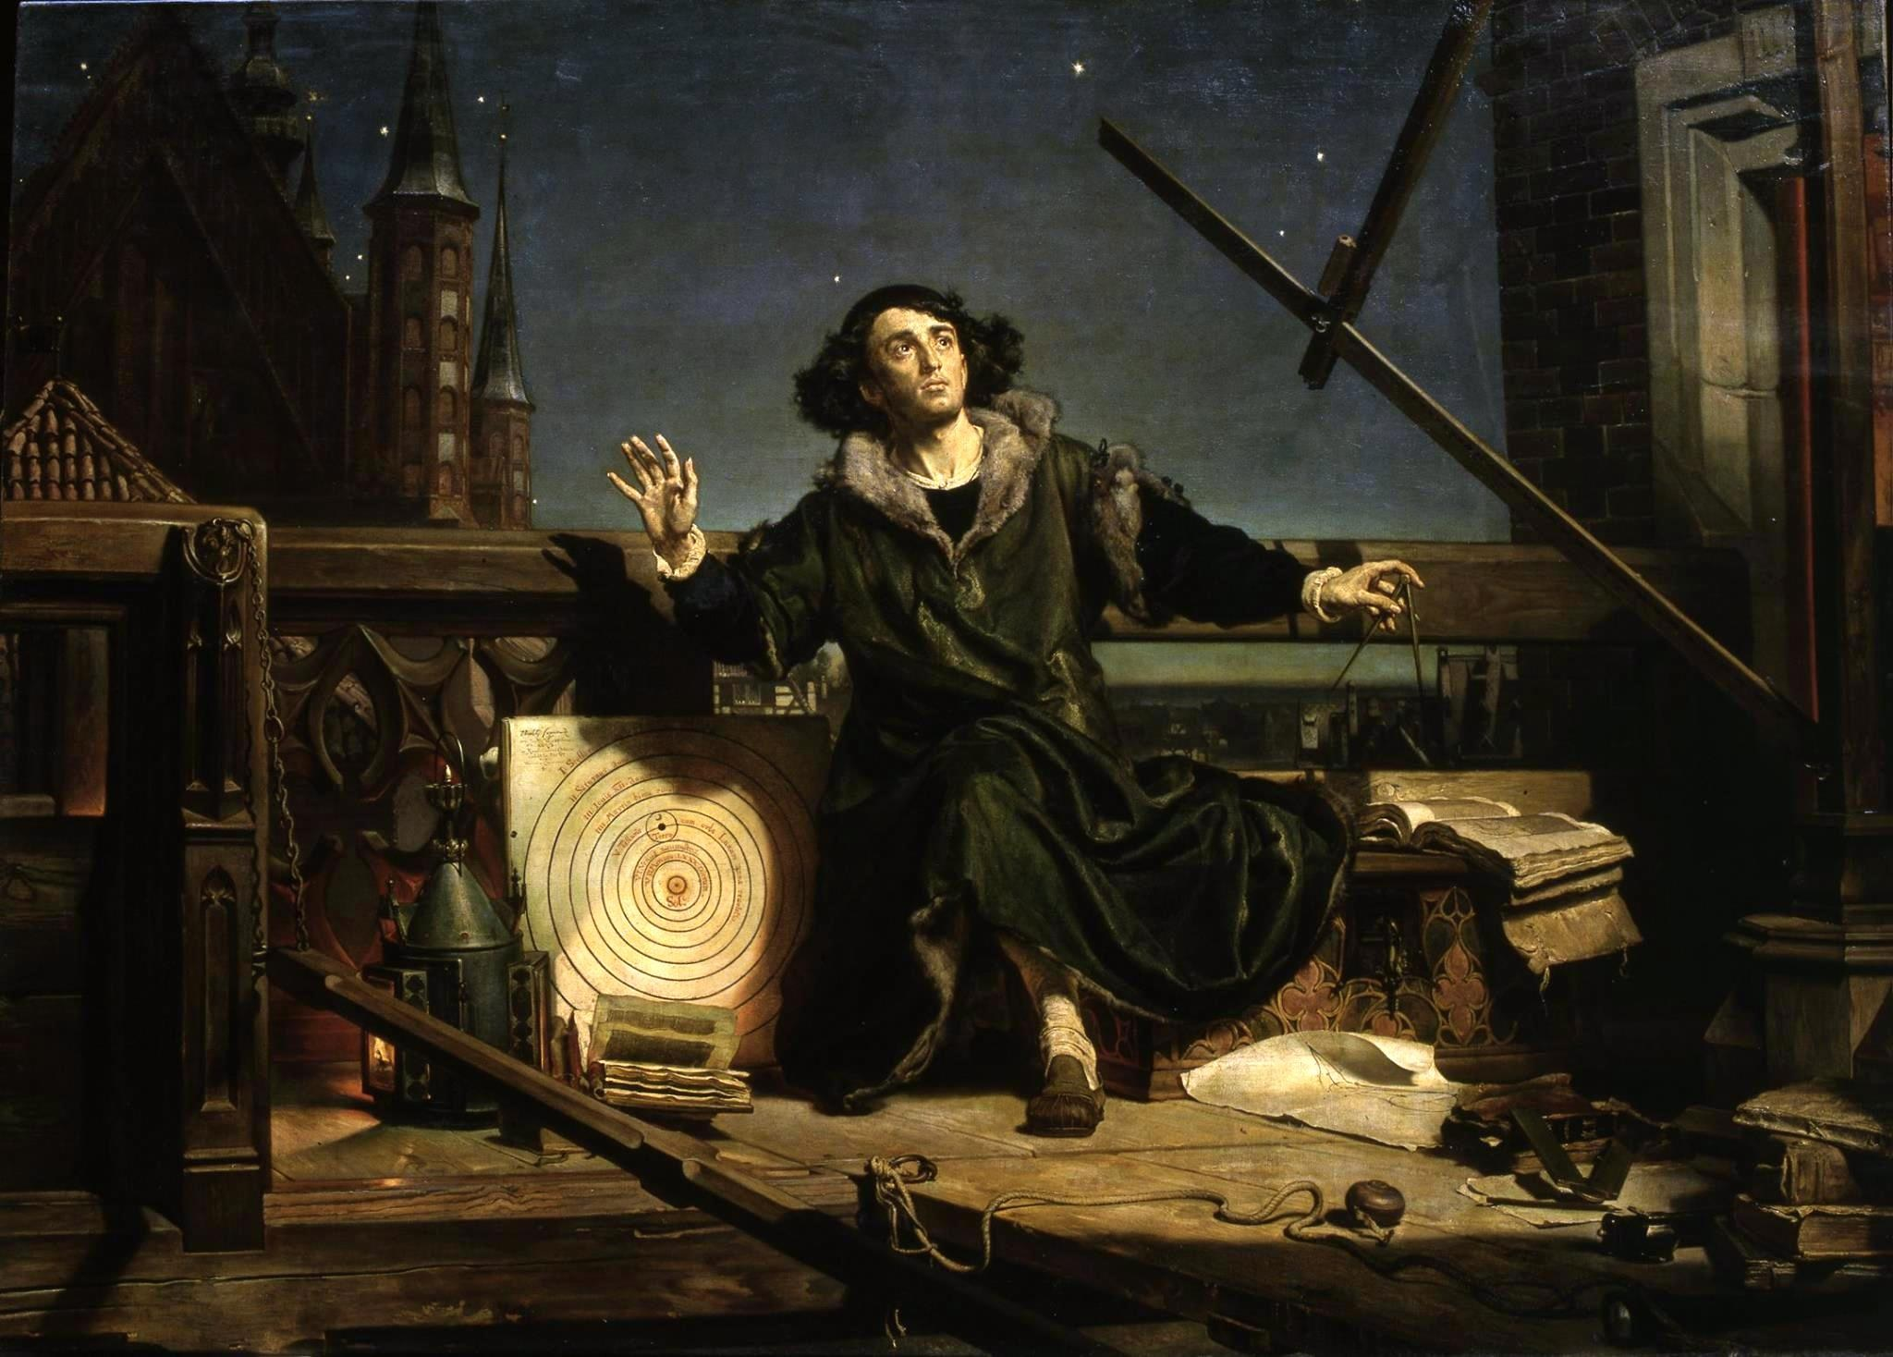
Jan Matejko: „Astronomer Copernicus, or Conversations with God”. It shows Copernicus during his observations of the sky from his private tower on a cathedral hill in Frombork.
Source: https://goo.gl/images/xbHry3

Task 1:
- Frombork - Kopernik lived here for 48 years as a canon. He died here on 24 May 1543 (aged 70).
In Frombork Copernicus conducted over half of his more than 60 registered astronomical observations. Having settled permanently in Frombork, where he would reside to the end of his life, with interruptions in 1516–19 and 1520–21, Copernicus found himself at the Warmia chapter's economic and administrative centre, which was also one of Warmia's two chief centres of political life. Here he wrote his greatest work "De revolutionibus orbium coelestium".

- Lidzbark - Copernicus was his uncle's secretary and doctor from 1503 to 1510 (or perhaps till his uncle's death on 29 March 1512) and resided in the Bishop's castle at Lidzbark (Heilsberg), where he began work on his heliocentric theory.

- Olsztyn - During 1516–21, Copernicus resided at Olsztyn (Allenstein) Castle as economic administrator of Warmia, including Olsztyn and Pieniężno. While there, he wrote a manuscript, Locationes mansorum esertorum (Locations of Deserted Fiefs), with a view to populating those fiefs with industrious farmers and so bolstering the economy of Warmia. When Olsztyn was besieged by the Teutonic Knights during the Polish – Teutonic War, Copernicus was organizing the defence of the city against the expected attack.
- Toruń - Kopernik was born here on 19 February 1473 in the family of a trader Mikołaj Kopernik and Barbara Watzenrode
- Padova – he studied here at the University of Padova 1501-1503. He studied law, medicine and Greek philology
- Ferrara – he studied at the University of Ferrara in 1503. He studied the canon law.
- Bologna - he studied at the University of Bologna in 1496-1500. He studied law, fine arts and medicine.

Task 2
a | s | t | r | o | n | o | m | e | r | p | a
d | o | v | a | d | o | c | t | o | r | f | r
o | m | b | o | r | k | t | r | a | n | s | l
a | t | o | r | t | o | r | u | ń | m | a | t
h | e | m | a | t | i | c | i | a | n | b | o
l | o | g | n | a | l | a | w | y | e | r | k
r | a | a | k | ó | w | e | c | o | n | o | m
i | s | t | f | e | r | r | a | r | a | a | s
t | r | o | l | o | g | e | r | o | l | s | z
t | y | n | s | t | r | a | t | e | g | i | s
t | l | i | d | z | b | a | r | k

Task 3
AREA | ASTRONOMY | GEOMETRY | ECONOMY
theory | 2 | 3 | 1
illustration | C. | A. | B.
source: Wikipedia

