Europe’s fun sports and great sports people

LESSON PLAN

Module 15 “Europe’s fun sports”

Topic: “GAMES WITHOUT FRONTIERS”

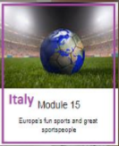

TEACHERS : ITALIAN TEAM

TIME: a year
RECIPIENTS: SECOND CLASSES SECONDARY SCHOOL I.C.ERODOTO
INVOLVED SUBJECTS: Geography, Physical Education,
L 1 and L 2, History and Maths .

Aims
The students will:
• Know the major games of the "GAMES WITHOUT FRONTIERS" competition.
• Compare the various challenges of the Competition.

Expected results
• -to observe the particularities of the different games
• -to describe group games and individual games
• -to describe outdoor and indoor games

Teaching form

Lab activities

Teaching methods
Frontal, group and work in pairs, method of speech, demonstrative, method of research, work with text and illustrative method

Materials
- Books, pictures, computer – presentations, posters, photos, brochures, markers, colours, glue, scissors, board
- projector, screen
- speakers
- laptop or computer with the Internet connection
- tablets with QR scanners
- worksheets

Instructions
Stage 1: INTRODUCTION
Discussion about the fun typical games of the Competition entitled "Games without frontiers":
• Research about the origins and the history of the „Games without frontiers”.
• Discussion about the difference of the most diffused games in outdoor and indoor challenges
• Identification of the nations involved.
• Identification of the funniest games played in the challenges.

www. Giochi senza frontiere.net
www.lettera 43.it
https://www.nonciclopedia.wikia.com
https://www.wikipedia.org
www.giochi senza frontiere Valdarnowww.famigros.micros.ch

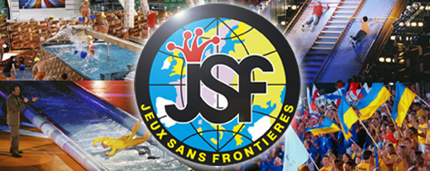

Stage 2: PRESENTATION
The biggest games of the Competition (Tug of war, throwing water bombs, shots on goal, hula-hoop snake)

STAGE 3: GROUPWORK
- Divide the classes into groups, make a ranking about the most common and pleasant games and start the competition chosen among those proposed by the group leaders.

b) Appoint a group leader who will coordinate the challenge.

c) The groups will be given a fixed time to carry out the competition between the trained groups

STAGE 4: CONSOLIDATION
In the end the winning boys will be rewarded

Italian team

