TOPIC: The EU and Its Four Freedoms.

AIMS:
The students:
- know the basic rules of the European Single Market (the four freedoms: free movement of goods, capital, services, and labour);
- can mention some benefits for themselves as EU citizens;
- can work in a group;
- can present the results of their work.

LESSON PLAN:

- Introduction: a short review of what the European Union is. Watching a short video and sharing information on what the students remember (worksheet 1):

- Dividing the class into groups.

- Groupwork:
- Wordsearch – “Free movement of goods, capital, services, and labour” (worksheet 2):
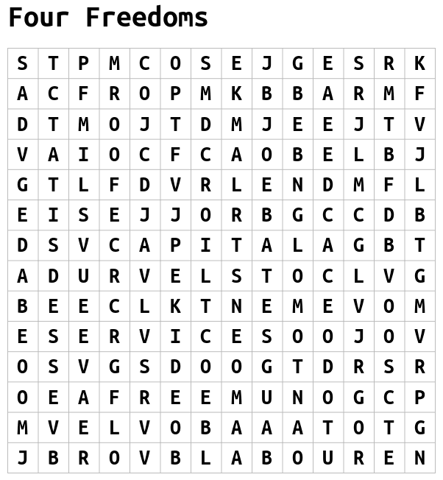
- Working with mobile devices (tablets, smartphones etc); scanning the QR codes leading to short video clips about the European Union, also accessible from the website:
https://www.europarltv.europa.eu/pl/category/society





- Watching one spot in a group and noting down as many pieces of information as possible, providing answers to the question: What do I gain / What rights do I have as a citizen of the European Union?
- Writing the examples, based on the video clips watched by the group, on the cards prepared by the teacher (worksheet 3).
- Matching the examples with the freedoms that the group discovered in the word search activity.

If needed, one can use some informative websites, like e.g.:
https://fullfact.org/europe/what-single-market

- Groupwork presentation: one student, a class “reporter”, asks each group to present the results of their research, by asking them a question:
How do you benefit from being EU citizens?
Another student, a class “cameraman”, films the groups’ answers, then edits the filmed material and makes a class video on the EU freedoms.

Prepared by: Ewa Kowalska

WORKSHEET 1:
What is the European Union? Watch this short clip and try to remember!
WORKSHEET 2:

Discover the “Four Freedoms” of the European Union.

SOLUTION:
________________________________________________________________________________

WORKSHEET 3:

Watch at least one of the video clips and note down as many examples as possible to answer the question:
“What do I gain / What rights do I have as a citizen of the European Union”?

…………………………………………………………………………………………………………………………………………………………
…………………………………………………………………………………………………………………………………………………………
…………………………………………………………………………………………………………………………………………………………
…………………………………………………………………………………………………………………………………………………………
…………………………………………………………………………………………………………………………………………………………
…………………………………………………………………………………………………………………………………………………………
…………………………………………………………………………………………………………………………………………………………
…………………………………………………………………………………………………………………………………………………………
…………………………………………………………………………………………………………………………………………………………
…………………………………………………………………………………………………………………………………………………………
…………………………………………………………………………………………………………………………………………………………
…………………………………………………………………………………………………………………………………………………………
…………………………………………………………………………………………………………………………………………………………

