TRAVELING AROUND EUROPE

LESSON PLAN

Module 23 “TRAVELING AROUND EUROPE”

Topic: “Traveling to know the European capitals”

Teachers: Italian team
Time: a year
Recipients: Second Classes Secondary School of 1st degree I.C. "Erodoto"
Involved subjects: Geography, L1, L2, History, Art , Music, Religion.

Aims
The students will:
• Acquire the traveler's modus vivendi
• Be able to travel even with imagination
• Be able to draw up a route
• Develop motivation to learn and explore
• Know and discover new places and European cities
• Be aware that traveling means enriching oneself and promoting cultural exchanges
• Be able to orientate themselves in space

Expected results
To know and recognize European capitals
• to orientate oneself in space
• to observe the particularities of the different European places and cities
• to describe some elements of various European places and cities

Teaching form

Lab activities

Teaching methods

Frontal, group and work in pairs, method of speech, demonstrative, method of research, work with text and illustrative method, leaning games (kahoot), google mapps.

Materials
- Books, pictures, computer – presentations, posters, photos, brochures, markers, colours, glue, scissors, board, projector, screen, speakers, laptop or computer with the Internet connection, tablets with QR scanners, worksheets

Instructions
Stage 1: INTRODUCTION
To study Europe from a geographical point of view
To identify the EU countries
To Study European capitals
To discuss about the peculiarities of every European capital
To outline a route that crosses the capitals
To tell lived experiences.

Stage 2: PRESENTATION

The knowledge of European capitals occurs using the travel metaphor. Each student identifies himself with the traveler of the moment to discover the European capitals. Students are asked to choose and define an itinerary drawn up using new technologies, ex: google map. Afterwords, using the maps of the capitals, the students identify the cities: the monuments, buildings, street art works, traditions, shopping centres, parks and green areas.
For example, the knowledge of the capitals that are crossed by the Danube or routes that depart from one capital and arrive in another will be proposed.

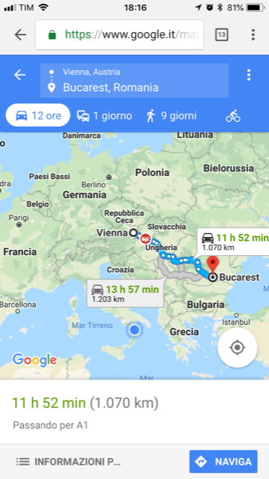

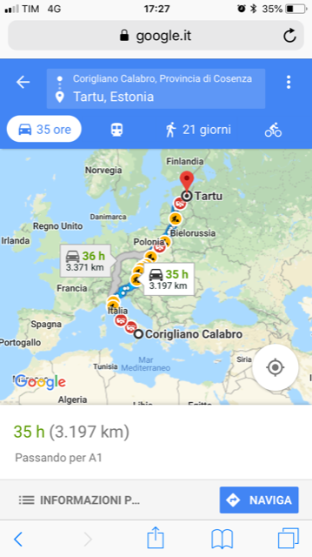

STAGE 3: GROUPWORK
- Finally, when pupils have acquired geographical skills on the knowledge of Europe
it will be possible to work in the classes dividing the pupils into groups (no larger than 4 students each), each group will be asked to outline an itinerary that covers some of the European capitals.
b) The groups will be given a fixed time of one hour to define the itinerary and describe the particular aspects of the capitals chosen.
c) Each group will have a spokesman who will be giving the task of describing its own itinerary.

STAGE 4: CONSOLIDATION
In the consolidation phase, students will be asked to recognize the capitals through the vision of symbols, monuments, palaces, parks, streets, etc., previously designed.

TASK 1:
Using a blank map of Europe, either on paper or in digital format, to be imported from a graphic program (eg Paint or Photoshop), pupils, divided into groups, outline an itinerary that crosses at least five European capitals.

TASK 2:
The students, divided into groups, draw the most important monuments of the cities next to the names of the various European capitals and describe the work in writing briefly.
Tallin Estonia
Varsavia Polonia
Bucarest Romania
Skopje Macedoni
Roma Italia
Parigi Francia
Madrid spagna
Londra Inghilterra
Lisbona Portogallo
Atene Grecia

TASK 3:

CARD GAME „ Traveling around Europe”
After having created a certain number of cards on which are listed the names of European capitals, states, drawings of monuments representative of Europe and the EU, we can form at least four teams who are asked, at the same time, to report: if it is a capital , of the State of belonging, if it is a State of its capital, if it is a monument which is and where it is located.

Author:
Italian team

