OPERATIONAL LESSON PLAN
Teacher | Dochița Raluca
Class | I-first class
Date | 19.06.2018
Module7 | Europe - a mosaic of cultures and religions  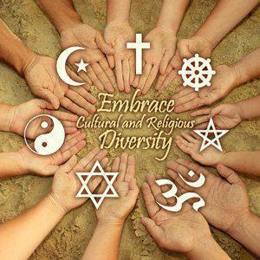
Content | Traveling in Europe
Teaching forms | Frontal, group and work in pairs
Teaching methods | Method of speech, demonstrative, method of research, work with text and illustrative method
Teaching resources | Pictures, computer – presentations ,posters, photos, brochures, markers, colours, glue, scissors, board, chalks in different colours, an overhead projector, laptop or computer with the internet access
Aim of the lesson | -Acquiring new informations about cultures and religinions in Europe;  -Accepting diversity in culture and religion;  -Students will identify types of cultural commonalities and cultural differences across European regions.  -Students will use a variety of authentic artifacts collected by teachers during their travels across Europe.  -Students will study the idea that European culture is differed greatly by geographic region, as well as individual countries.  -Students will research a variety of resources to discover other cultural traits of Europe.
Expected results | -to observe he particularities of the different religions and cultures of Europe  -to describe some elements of various religions and european cultures  -to explain in their ownwords the term of religious and cultural diversity  -to observe customs and traditions from different regions of Europe  -to work in a team to create the newspaper that illustrates the European cultural and religious variety

Articulation of the lesson
Introductory activities | The lesson begins with the presentasion of a movie about cultures and religions in Europe.  After the presentation, there will be a conversation on the topic.  https://www.youtube.com/watch?v=Wxeimb8trDM  https://www.youtube.com/watch?v=lprbad_J5W8
Teaching and learning activities | Students will be presented with a map of Europe. Teachers will read “A Journey Across Europe,” pausing, and giving time to discuss all coordinate locations. Students will locate and identify the cities visited with parents. Students will also chart the journey on their map of Europe. Teachers will briefly discuss the places visited (discussion will be ongoing throughout the unit). Students will respond to the following question in their journals: What kind of people did you meet(cultures /religions? How did you feel coming in contact with people from different cultures and religions? Students will discuss concept with classmates and teachers. As a follow up, teachers will define, and discuss the various geographic regions in Europe (glossary provided in teacher and student packet). Teachers will specify which countries belong to each region (Northern, Southern, Eastern, and Western Europe).
Evaluative activities | Journaling across the Europe  The students will produce a newspaper in wich they will  Present with drawings, pictures, collages of a various cultures and religions from Europe.they will work in the team.  After this a designated reporter will shortly present an article from the newspaper.

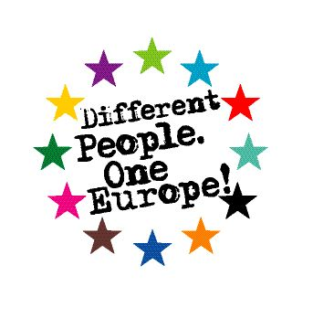
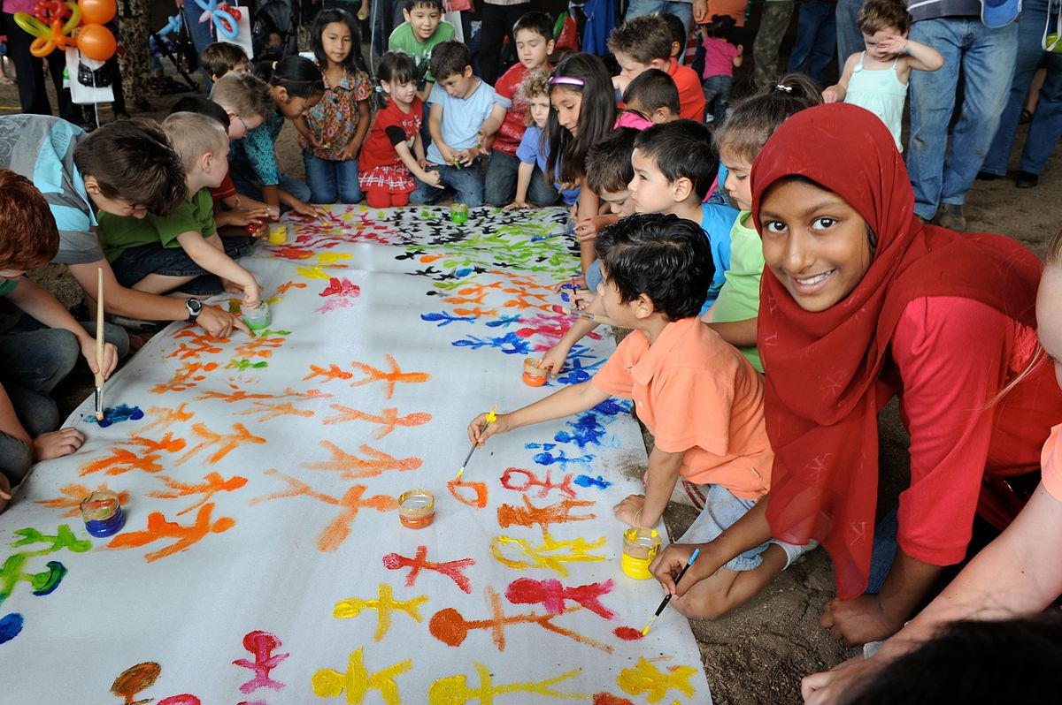
HELPING MATERIALS

